Kubernetes

## Certification Details

Certified Kubernetes Administrator: <https://www.cncf.io/certification/cka/>

Exam Curriculum (Topics): <https://github.com/cncf/curriculum>

Candidate Handbook: <https://www.cncf.io/certification/candidate-handbook>

Exam Tips: [http://training.linuxfoundation.org/go//Important-Tips-CKA-CKAD](http://training.linuxfoundation.org/go/Important-Tips-CKA-CKAD)

<https://kodekloud.slack.com/join/shared_invite/enQtNzU2Mjk4MTI5NDkwLTdjYzc0ZmI5MjU1NGUzMzgxMWFhNDgyNjZhZGVjNjRhYjc2NTgzZTcyN2FiODkyZWQ5NGQ4MzY3NWU2NzAwMjU>

Cluster Architecture

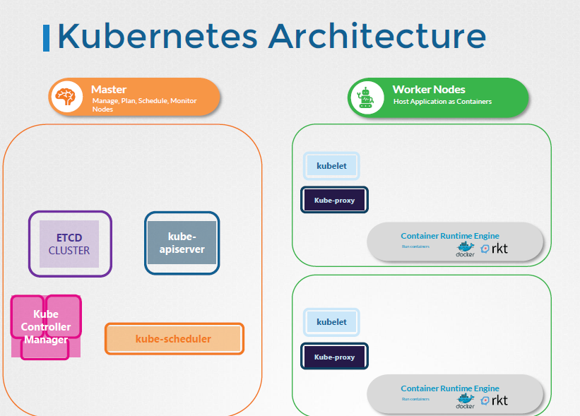

worker node = cargo ships that carry containers

Control Node= load the containers on the cargo ship, plan how to load, identify the right ships, monitor and track the location of the containers on the ships, monitor, manage the loading process

Etcd=maintain information about different ships, containers that are running, what time it was loaded

=highly available key value store, database

Scheduler= craines identify the containers to be placed on ships, identifies the right ship based on its capacity, the number of containers already on the ship and other conditions (destination of the ship, type of containers it is allowed to carry etc.)

!! identifies the right node to place a container based on the C resource requirement, worker capacity, or any other policy or constraint (node affinity rules,

NodeController = takes care of nodes (cargo ships), onboarding new nodes to the cluster, handling situations where nodes become unavailable, gets destroyed,

Replication controller = desired number of containers are running all times in your replication

There are different offices in the dock that are assigned to special tasks or departments.

For example the operations team takes care of ship handling traffic control etc. they deal with issues

related to damages, the routes the different ship state etc. The cargo team takes care of containers

when continuous are damaged or destroyed.

They make sure new containers are made available.

You have these services office that takes care of the I.T. and communications between different ships.

The kube-apiserver is the primary management component of kubernetes. The kube-api server is responsible for

orchestrating all operations within the cluster.

It exposes the Kubernetes API which is used by externals users to perform management operations on

the cluster as well as the various controllers to monitor the state of the cluster and make the necessary

changes as required and by the worker nodes to communicate with the server.

A kubelet is an agent that runs on

each node in a cluster.

It listens for instructions from the kube-api server and deploys or destroys containers on the nodes

Worker

The captain is responsible for liaising with the master ships starting with letting the master ship

know that they are interested in joining the group receiving information about the containers to be

loaded on the ship and loading the appropriate containers as required sending reports back to the master

about the status of this ship and the status of the containers on the ship etc

Now the captain of the ship is the kubelet in Kubernetes. A kubelet is an agent that runs on

each node in a cluster.

It listens for instructions from the kube-api server and deploys or destroys containers on the nodes

as required.

The kube-api server periodically fetches status reports from the kubelet to monitor the state of nodes

and containers on them.

Communication between worker nodes are enabled by another component that runs on the worker node known

as the Kube-proxy service. The Kube-proxy service ensures that the necessary rules are in place on the

worker nodes to allow the containers running on them to reach each other.

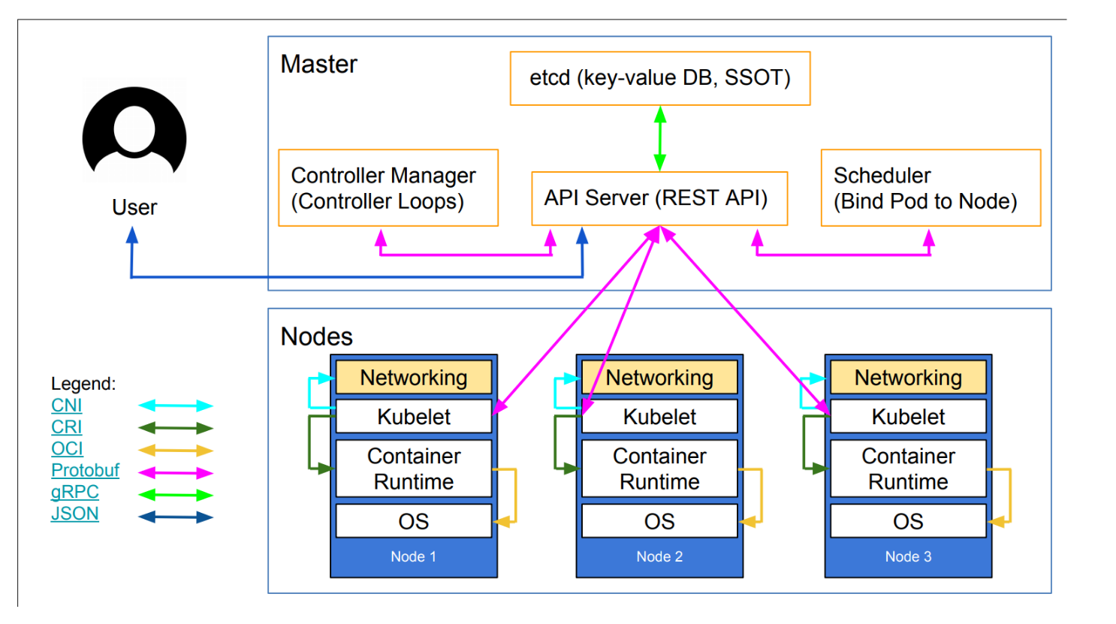

API server

Earlier we discussed that the Kube-api server is the primary management component in kubernetes. When

you run a kubectl command, the kubectl utility is infact reaching to the kube-apiserver.

The kube-api server first authenticates the request and validates it. It then retrieves the data from the

ETCD cluster and responds back with the requested information.

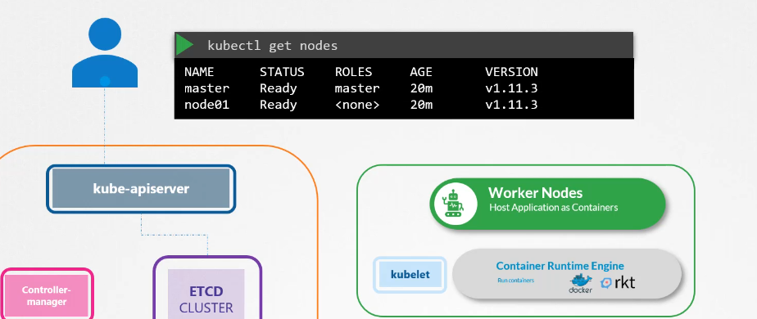

You don’t really need to use the kubectl command line.

Instead, you could also invoke the API directly by sending a post request like this let's look at an

example of creating a pod when you do that as before the request is authenticated first and then validated.



In this case, the API server creates a POD object without assigning it to a node, updates the information in the ETCD. server updates the user that the POD has been created.

The scheduler continuously monitors the API server and realizes that there is a new pod with no node

assigned the scheduler identifies the right node to place the new POD on and communicates that back

to the kube-apiserver.

The API server then updates the information in the ETCD cluster. The API server then passes that information

to the kubelet in appropriate worker node.

The kubelet then creates the POD on the node and instructs the container runtime engine to deploy the

application image.

Once done, the kubelet updates the status back to the API server and the API server then updates the

data back in the ETCD cluster. A similar pattern is followed every time a change is requested.

The kube-apiserver is at the center of all the different tasks that needs to be performed to make a

change in the cluster.

To summarize, the kube-api server is responsible for Authenticating and validating requests, retrieving

and updating data in ETCD data store,

in fact, kube-api server is the only component that interacts directly with the etcd datastore.

The other components such as the scheduler, kube-controller-manager & kubelet

uses the API server to perform updates in the cluster in their respective areas.

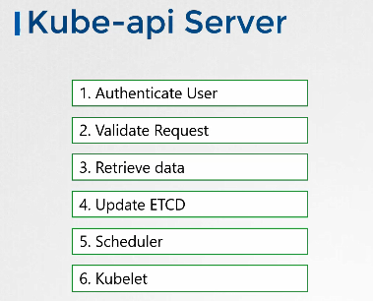

If you bootstrapped your cluster using kubeadm tool then you don't need to know this but if you are setting up the hard way, then kube-apiserver is available as a binary in the kubernetes release

page. Download it and configure it to run as a service on your kubernetes master node.

The kube-api server is run with a lot of parameters as you can see here. Throughout this section

we are going to take a peak at how to install and configure these individual components of the kubernetes architecture.

You don't have to understand all of the options right now but I think having a high level understanding on some of these now will make it easier later when we configure the whole cluster and all of its components from scratch.

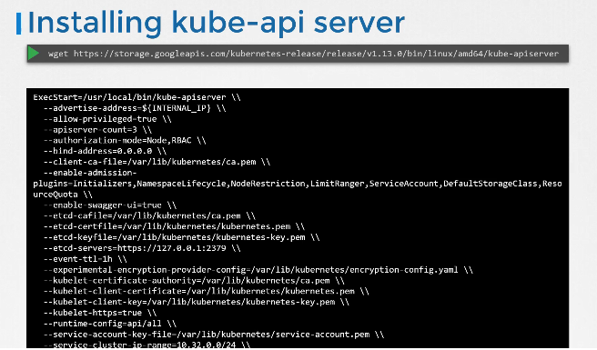

The kubernetes architecture consists of a lot of different components working with each other, talking to each other in many different ways so they all need to know where the other components are.

There are different modes of authentication, authorization, encryption and security. And that’s why you have so many options when we go through the relevant section in the course we will pull up this file and look at the relevant options.

For now we will look at a few important ones.

A lot of them are certificates that are used to secure the connectivity between different components.

We look at these certificates in more detail when we go through the SSL/TLS certificates lecture later

in this course.

There is a whole section just for it. So we will get rid of them for now.

But just remember all of the various components we are going to look at in this section will have certificates

associated with them. The option ETCD-servers is where you specify the location of the ETCD servers.

This is how the kube-api server connects to the etcd servers.

So how do you view the kube-api server options in an existing cluster

It depends on how you set up your cluster.

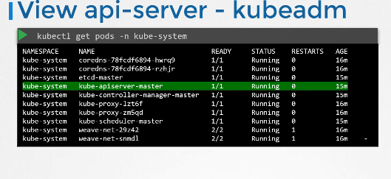

If you set it up with kubeadm tool, kubeadm deploys the kube-api server as a pod in the kube-

system namespace on the master node you can see the options within the pod definition file located at etc kubernetes manifests folder. etc kubernetes manifests folder.

kube-apiserver service located at /etc/systemd/system/kube-apiserver.service.You can also see

the running process and the effective options by listing the process on the master node and searching for kube-apiserver.

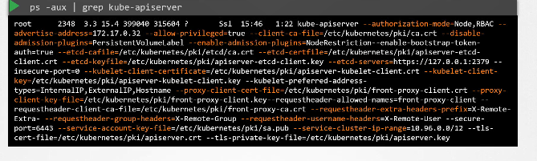

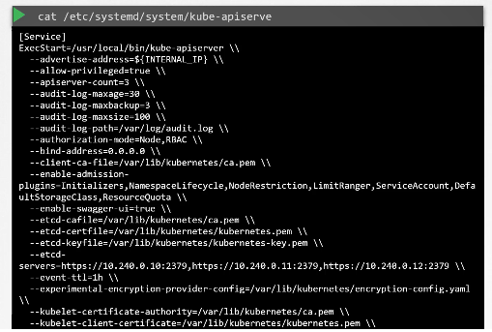

## Controller Manager

As we discussed earlier, the kube controller manager manages

various controllers in Kubernetes. A controller is like an office or department within the master ship

that have their own set of responsibilities. Such as an office for the Ships would be responsible for

monitoring and taking necessary actions about the ships.

Whenever a new ship arrives or when a ship leaves or gets destroyed another office could be one that

manages the containers on the ships they take care of containers that are damaged or full of ships.

So these officers are number 1, continuously on the lookout for the status of the ships and 2, take

necessary actions to remediate the situation. In the kubernetes terms

a controller is a process that continuously monitors the state of various components within the system

and works towards bringing the whole system to the desired functioning state.

For example the node controller is responsible for monitoring the status of the nodes and taking necessary

actions to keep the application running.

It does that through the kube-api server.

The node controller checks the status of the nodes every 5 seconds.

That way the node controller can monitor the health of the nodes if it stops receiving heartbeat from

a node the node is marked as unreachable but it waits for 40 seconds before marking it unreachable after

a node is marked unreachable it gives it five minutes to come back up if it doesn’t, it removes the

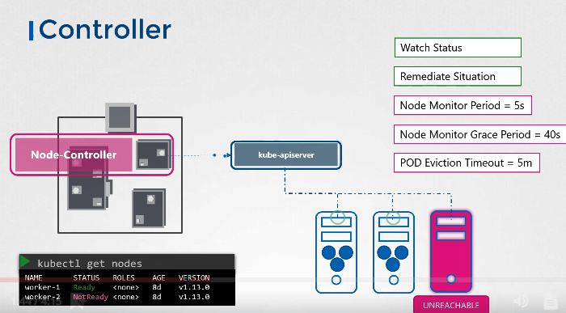

PODs assigned to that node and provisions them on the healthy ones.

If the PODs are Pod of a replica set the next controller is the replication controller.

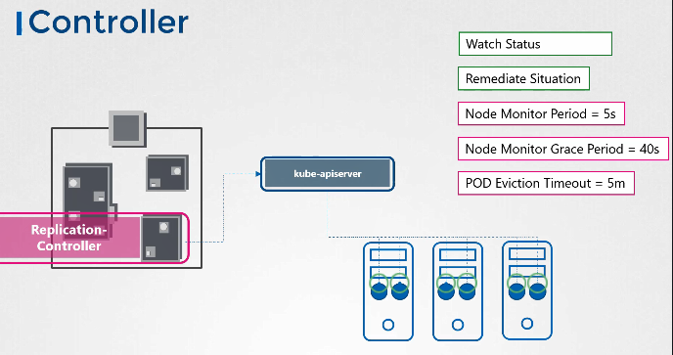

It is responsible for monitoring the status of replica sets and ensuring that the desired number of PODs are available at all times within the set.

If a pod dies it creates another one.

Now those were just two examples of controllers.

There are many more such controllers available within kubernetes.

Whatever concepts we have seen so far in kubernetes such as deployments, Services, namespaces, persistent volumes and whatever intelligence is built into these constructs it is implemented through

these various controllers.

As you can imagine this is kind of the brain behind a lot of things in kubernetes.

Now how do you see these controllers and where are they located in your cluster.

They're all packaged into a single process known as kubernetes controller manager.

When you install the kubernetes controller manager the different controllers get installed as well.

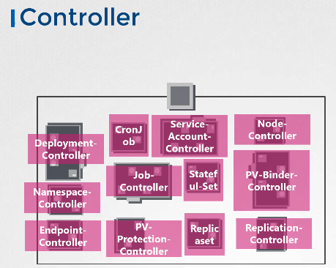

So how do you install and view the kubernetes

Controller manager download the kube-controller-manager from the kubernetes release page. Extract it and run it as a service.

When you run it as you can see there are a list of options provided this is where you provide additional options to customize your controller.

Remember some of the default settings for node controller we discussed earlier such as the node monitor period the grace period and the eviction timeout.

These go in here as options.

There is an additional option called controllers that you can use to specify which controllers to enable.

By default all of them are enabled but you can choose to enable a select few.

So in case any of your controllers don't seem to work or exist this would be a good starting point to look at.

So how do you view the Kube-controller-manager server options?

Again it depends on how you set up your cluster.

If you set it up with kubeadm tool, kubeadm deploys the kube-controller-manager as a pod in the kube-system namespace on the master node. You can see the options within the pod definition file located

at /etc/kubernetes manifests folder.

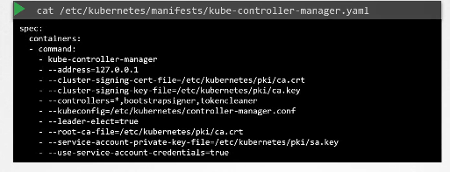

In a non-kubeadm setup, you can inspect the options by viewing

the kube-controller-manager service located at the services directory.

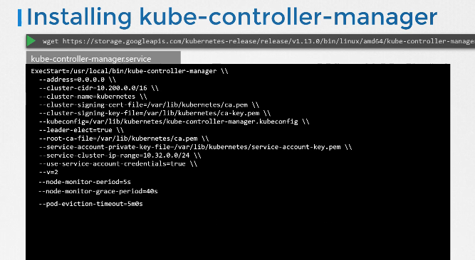

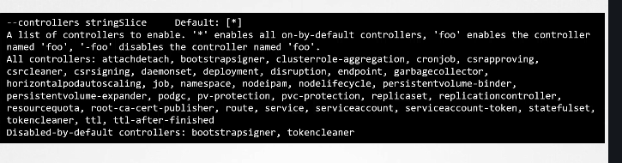

You can also see the running process and the effective options by listing the process on the master

node and searching for kube-controller-manager.

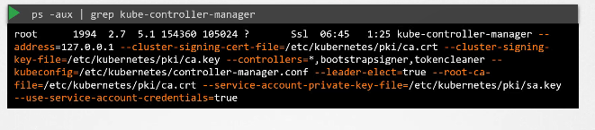

## Kube Scheduler

Earlier we discussed that the kubernetes scheduler is responsible for scheduling pods on nodes.

Now don't let the graphic mislead you.

remember the scheduler is only responsible for deciding which pod goes on which node. It doesn’t actually

place the pod on the nodes.

That’s the job of the kubelet. The kubelet or the captain on the ship is who creates the pod on the

ships.

The scheduler only decides which pod goes where.

Let's look at how the scheduler does that in a bit more detail.

First of all why do you need a scheduler? When there are many ships and many containers,

You want to make sure that the right container ends up on the right ship.

For example there could be different sizes of ships and containers.

You want to make sure the ship has sufficient capacity to accommodate those containers different ships

maybe going to different destinations.

You want to make sure your containers are placed on the right ships so they end up in the right destination

In kubernetes, the scheduler decides which nodes the pods are placed on

depending on certain criteria. You may have PODs with different resource requirements,

You can have nodes in the cluster dedicated to certain applications.

So how does the scheduler assign these PODs? The scheduler looks at each POD and tries to find the

best node for it.

For example, let’s take one of these PODs.

The big blue one. It has a set of CPU and Memory requirements.

The scheduler goes through two phases to identify the best node for the pod in the first phase.

The scheduler tries to filter out the nodes that do not fit the profile for this pod.

For example, the nodes that do not have sufficient CPU and memory resources requested by the pod.

So the first two small nodes are filtered out. So we are now left with two nodes on which the POD

can be placed.

Now how does the scheduler pick one from the two the scheduler ranks the node to identify the best fit

for the pod.

It uses a priority function to assign a score to the nodes on a scale of 0 to 10.

For example the scheduler calculates the amount of resources that would be free on the nodes after placing

the pod on them.

In this case, the one on the right would have 6 CPUs free if the pod was placed on it which is 4 more

than the other one so it gets a better rank.

And so it wins.

So that's how a scheduler works at a high level.

And of course these can be customized and you can write your own scheduler as well.

There are many more topics to look at such as resource requirements, limits, taints and tolerations,

node selectors, affinity rules etc. Which is why we have an entire section dedicated to scheduling coming

up in this course where we will discuss each of these in much more detail.

For now we will continue to focus on the scheduler as a process at a high level.

So how do you install the kube-scheduler?

Download the kube-scheduler from the kubernetes release page. Extract it and run it as a service.

when you run it as a service.

You specify the scheduler configuration file.

So how do you view the kube-scheduler server options?

Again, if you set it up with kubeadm tool, kubeadm deploys the kube-scheduler as a pod

in the kube-system namespace

on the master node. You can see the options within the pod definition file located at etc

kubernetes manifests folder.

You can also see the running process and the effective options by listing the process on the master

node and searching for kube-scheduler.

Well that's it for this lecture.

I will see you in the next.

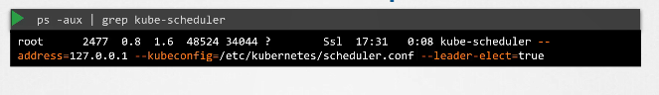

## Kubelet

Hello and welcome to this lecture. In this lecture

we will look at kubelet.

Earlier we discussed that the kubelet is like the captain on the ship. They lead all activities on

a ship.

They're the ones responsible for doing all the paperwork necessary to become Pod of the cluster,

They're the sole point of contact from the master ship.

They load or unload containers on the ship as instructed by the scheduler on the master.

They also send back reports at regular intervals on the status of the ship and the containers on them.

The kubelet in the kubernetes worker node, registers the node with the kubernetes cluster.

When it receives instructions to load a container or a POD on the node, it requests the container run time

engine, which may be Docker, to pull the required image and run an instance.

The kubelet then continues to monitor the state of the POD and the containers in it and reports to the kube-api

server on a timely basis.

So how do you install the kubelet? If you use kubeadm tool to deploy your cluster, it does not

automatically deploy the kubelet.

Now that's the difference from the other components.

You must always manually install the kubelet on your worker nodes. Download the installer, extract

it and run it as a service.

You can view the running kubelet process and the effective options by listing the process on the worker

node and searching for kubelet.

We will look more into kubelets, how to configure kubelets, generate certificates, and finally how

to TLS bootstrap kubelets later in this course.

That's it for now.

Will see you in the next lecture.

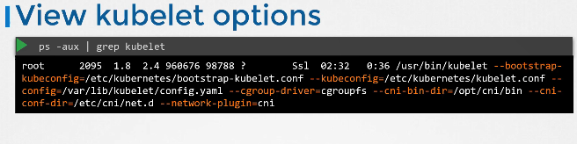

## Kube-proxy

Hello and welcome to this lecture. In this lecture, we will talk about Kube Proxy. Within a kubernetes

cluster every pod can reach every other pod.

This is accomplished by deploying a POD networking solution to the cluster. A POD network is an internal virtual network that spans across all the nodes in the cluster to which all the PODs connect to. Through this network are able to communicate with each other.

There are many solutions available for deploying such a network.

In this case I have a web application deployed on the first node and a database application deployed on the second.

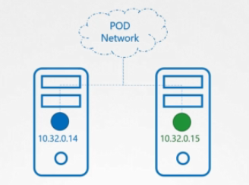

The web app can reach the database, simply by using the IP of the database POD.

But there is no guarantee that the IP of the database Pod will always remain the same.

If you've gone through the lecture on services as discussed in the beginners course you must know that

a better way for the web application to access the database is using a service. So we create a service to expose the database application across the cluster.

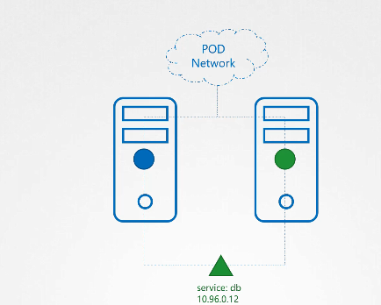

The web application can now access the database using the name of the service db.

The service also gets an IP address assigned to it whenever a pod tries to reach the service using its IP or name it forwards the traffic to the back end pod.

In this case the database.

But what is this service and how does it get an IP?

Does the service join the same POD Network?

The service cannot join the pod network because the service is not an actual thing.

It is not a container like pod so it doesn't have any interfaces or an actively listening process.

It is a virtual component that only lives in the cabinet as memory.

But then we also said that the service should be accessible across the cluster from any not.

So how is that achieved?

That’s where kube-proxy comes in.

Kube-proxy is a process that runs on each node in the kubernetes cluster.

Its job is to look for new services and every time a new service is created it creates the appropriate

rules on each node to forward traffic to those services to the backend pods.

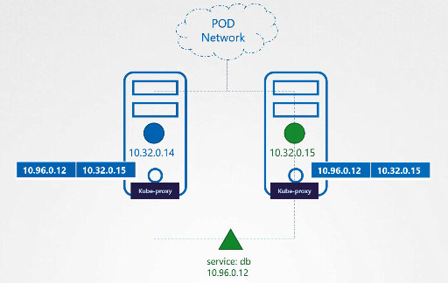

One way it does this is using IPTABLES rules.

In this case it creates an IP tables rule on each node in the cluster to forward traffic heading to the IP of the service which is 10.96.0.12 to the IP of the actual pod which is

10.32.0.15. So how kube-proxy configure the service

We discuss a lot more about networking and services kube-proxy and POD networking.

Later in this course again we have a large section just for networking.

This is a high level overview for now.

We will now see how to install kube-proxy.

Download the kube-proxy binary from the kubernetes release page. Extract it and run it as a service. The

kubeadm tool deploys kube-proxy as PODs on each node.

In fact it is deployed as a daemon set, so a single POD is always deployed on each node in the cluster.

Well if you don't know about daemon set yet don't worry we have a lecture on that coming up in this course.

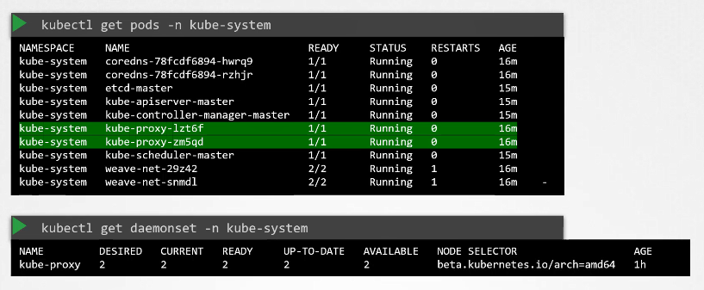

We have now covered a high-level overview of the various components in the kubernetes control plane.

As mentioned we will look at some of these in much more detail at various sections in this course.

Well that's it for this lecture.

## Replica Set

So what is a replica And why do we need a replication controller?

Let's go back to our first scenario where we had a single pod running our application.

What if for some reason our application crashes and the pod fails?

Users will no longer be able to access our application to prevent users from losing access to our application.

We would like to have more than one instance or pod running at the same time.

That way if one fails we still have our application running on the other one. The replication controller

helps us run multiple instances of a single POD in the kubernetes cluster

thus providing High Availability.

So does that mean you can't use a replication controller if you plan to have a single pod?

No.

Even if you have a single pod the replication controller can help by automatically bringing up a new

pod when the existing one fails.

Thus the replication controller ensures that the specified number of PODs are running at all times.

even if it's just 1 or 100. Another reason we need a replication controller is to create multiple PODs

to share the load across them.

For example in this simple scenario we have a single pod serving a set of users. When the number of users

increase

we deploy additional pod to balance the load across the two pods. If the demand further increases and

if we were to run out of resources on the first node we could deploy additional PODs across the other

nodes in the cluster.

As you can see the replication controller spans across multiple nodes in the cluster.

It helps us balance the load across multiple pods on different nodes as well as scale our application

when the demand increases. It's important to note that there are two similar terms replication controller

and Replica Set.

Both have the same purpose but they're not the same. Replication controller is the older technology that

is being replaced by Replica Set. Replica set is the new recommended way to setup replication.

However whatever we discussed in the previous few slides remain applicable to both these technologies.

There are minor differences in the way each works and we will look at that in a bit.

As such we will try to stick to Replica sets in all of our demos and implementations going forward.

Let us now look at how we create a replication controller.

As with the previous lecture we start by creating a replication controller definition file. We will name

name it rc-definition.yml. As with any kubernetes definition file,

We have four sections. The apiVersion, kind,

Metadata and spec the apiVersion is specific to what we are creating.

In this case replication controller is supported in kubernetes apiVersion v1.

So we will write it as v1. The kind as we know is ReplicationController. Under metadata,

we will add a name and we will call it myapp-rc. And we will also add a few labels, app and type

and assign values to them.

So far, it has been very similar to how we created a POD in the previous section.

The next is the most crucial Pod of the definition file and that is the specification written as spec.

For any kubernetes definition file, the spec section defines what’s inside the object we are creating.

In this case we know that the replication controller creates multiple instances of a POD. But what POD?

We create a template section under spec to provide a POD template to be used by the replication controller

to create replicas.

Now how do we define the POD template?

It's not that hard because we have already done that in the previous exercise.

Remember we created a pod-definition file in the previous exercise.

We could reuse the contents of the file to populate the template section. Move all the contents of the

pod definition file into the template section of the replication controller except for the first few

lines which are apiVersion and kind remember whatever we move must be under the template section. Meaning

this should be intended to the right and have more spaces before them

than the template line itself. They should be children of the template section. Looking at our file

now we now have two metadata sections.

One is for the Replication Controller and another for the POD

And we have two spec sections one for each.

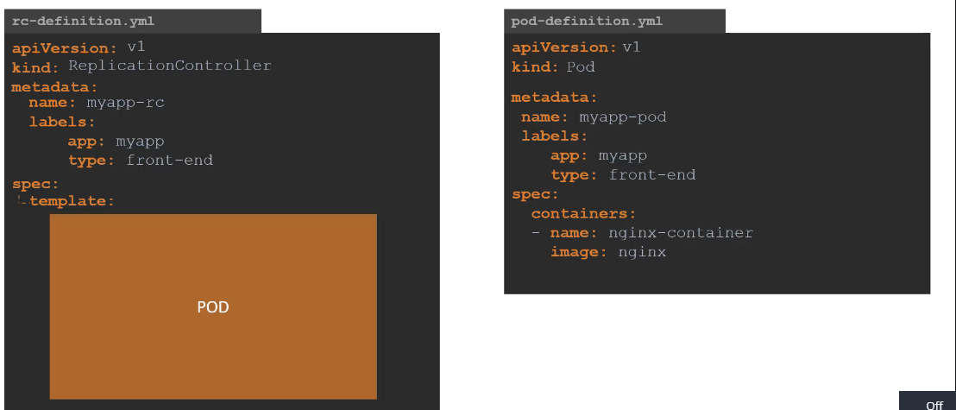

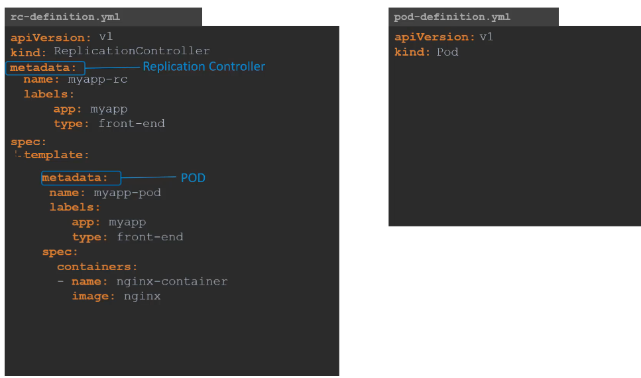

We have nested two definition files together.

The replication controller being the parent and the pod definition being the child. Now there is something

still missing.

We haven't mentioned how many replicas we need in the replication controller. For that,

add another property to the spec called replicas and input the number of replicas you need under it.

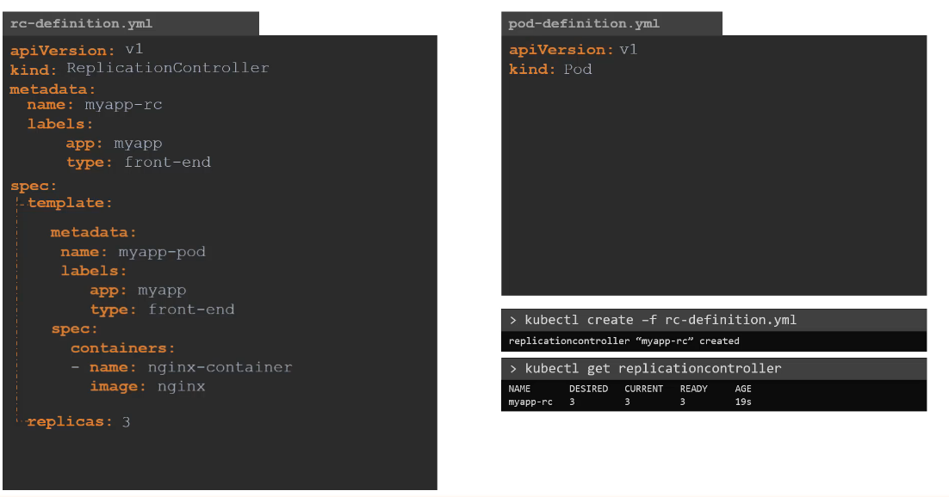

Remember that the template and replicas are direct children of spec sections. So they are siblings and

must be on the same vertical line which means having equal number of spaces before them. Once the file

is ready run the kubectl create command and input the file using the -f parameter. The replication

controller is created. When the replication controller is created it first creates the PODs using the

pod-definition template as many as required, which is 3

in this case. To view the list of created replication controllers run the kubectl get replication controller

command and you will see the replication controller listed.

We can also see the desired number of replicas or pods,

the current number of replicas and how many of them are ready in the output.

If you would like to see the pods that were created by the replication controller, run the kubectl

get pods command and you will see three pods running.

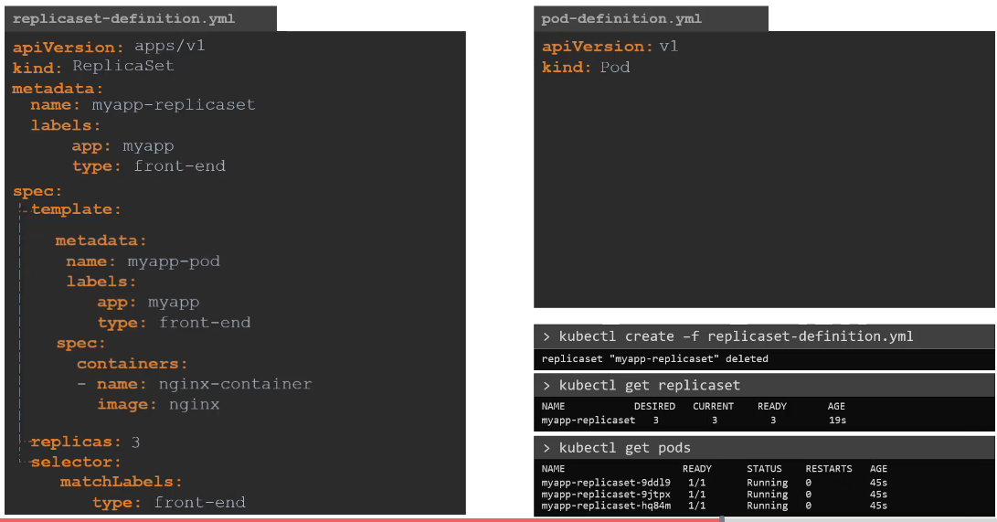

Note that all of them are starting with the name of the replication controller which is myapp-rc

indicating that they are all created automatically by the replication controller.

What we just saw was the Replication Controller.

Let us now look at replica set.

It is very similar to replication controller. As usual,

first we have apiVersion, kind,

metadata and spec. The apiVersion though is a bit different.

It is apps/v1 which is different from what we had before for replication controller which

was just V1.

If you get this wrong you are likely to get an error that looks like this.

It would say no match for a kind replica set because the specified kubernetes API version has no support

for replica set. The kind would be replica set and we add name and labels in the metadata.

The specification section looks very similar to replication controller.

It has a template section where we provide Pod definition as before.

So I am going to copy contents over from pod-definition file. And we have number of replicas which

is set to 3.

However there is one major difference between replication controller and replica set.

Replica set requires a selector definition. The selector section helps the replicaset identify what

pods fall under it. But why would you have to specify what PODs fall under it,

if you have provided the contents of the pod-definition file itself in the template? It’s because, replica

set can also manage parts that were not created as Pod of the public asset creation.

Say for example, there were pods created before the creation of the ReplicaSet that match the labels specified

in the selector.

The replica set will also take those pods into consideration when creating the replicas.

I will elaborate this in the next slide. But before we get into that I would like to mention that the

selector is one of the major differences between replication controller and replica set. The selector

is not a required field in case of a replication controller but it is still available. When you skip

it, as we did in the previous slide it assumes it to be the same as the labels provided in the pod definition

file. In case of replica said a user input is required for this property and it has to be written in

the form of match labels as shown here.

The match labeles selector simply matches the labels specified under it to the labels on the PODs.

The replica set selector also provides many other options for matching labels that were not available

in a replication controller.

And as always to create a replica set

run the kubectl create command providing the definition file as input and to see the created replicasets

run the kubectl get replicaset command. To get list of pods, simply run the kubectl get pods

command.

So what is the deal with labels and selectors.

Why do we label our PODs and objects in kubernetes?

Let us look at a simple scenario.

Say we deployed 3 instances of our frontend web application as 3 PODs.

We would like to create a replication controller or replica set to ensure that we have three active

PODs at anytime.

And yes that is one of the use case of replica sets.

You can use it to monitor existing parts if you have them already created.

As it is in this example in case they were not created the replica set will create them for you.

The role of the replicaset is to monitor the pods and if any of them were to fail, deploy new ones.

The replica set is in fact a process that monitors the parts.

Now how does the replica set know what pods to monitor.

There could be 100s of other PODs in the cluster running different application.

This is where labelling our pods during creation comes in handy.

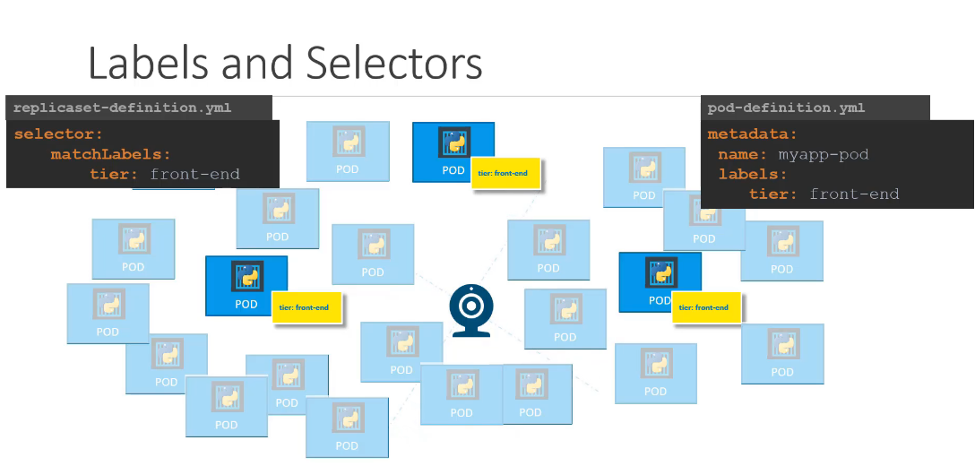

We could now provide these labels as a filter for replica set. Under the selector section we use to match

labels filter and provide the same label that we used while creating the pods.

This way the replica set knows which pods to monitor. The same concept of labels and selectors is used

in many other places throughout kubernetes.

Now let me ask you a question along the same lines. In the replicaset specification section

we learned that there are 3 sections: Template, replicas and the selector.

We need three replicas and we have updated our selector based on our discussion in the previous slide.

Say for instance we have the same scenario as in the previous slide were we have three existing pods

that were created already and we need to create a replica set to monitor the pods to ensure there are

a minimum of three running at all times.

When the replication controller is created it is not going to deploy a new instance of pods as three

of them with matching labels are already created.

In that case do we really need to provide a template section in the replica set specification.

since we are not expecting the replicaset to create a new POD on deployment? Yes we do because in case

one of the PODs were to fail in the future, the replicaset needs to create a new one to maintain the

desired number of PODs. And for the replica set to create a new POD,

The template definition section is required. Let’s look at how we scale the replicaset.

Say we started with three replicas and

In the future we decided to scale to six.

How do we update our replica set to scale to six replicas.

Well there are multiple ways to do it.

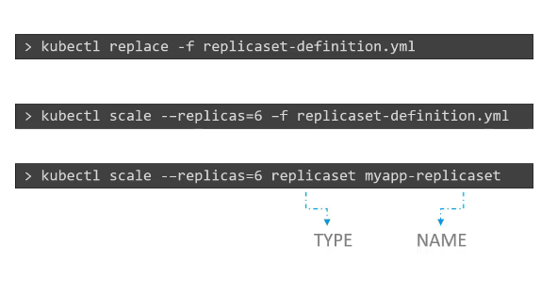

kubectl scale --replicas=2 replicaset new-replica-set

The first, is to update the number of replicas in the definition file to 6.

Then run the kubectl replace command specifying the same file using the –f parameter and that

will update the replica set to have six replicas.

The second way to do it is to run the kubectl scale command.

Use the replicas parameter to provide the new number of replicas and specify the same file as input.

You may either input the definition file or provide the replicaset name in the type Name format. However,

Remember that using the file name as input will not result in the number of replicas being updated

automatically in the file.

In otherwords, the number of replicas in the replicaset-definition file will still be 3 even

though you scaled your replicaset to have 6 replicas using the kubectl scale command and the

file as input.

There are also options available for automatically scaling the replica set based on load but that is

an advanced topic and we will discuss it at a later time. Let us now review the commands real quick. The

kubectl create command, as we know, is used to create a replca set or basically any object in Kubernetes

depending on the file we are providing as input.

You must provide the input file using the –f parameter. Use the kubectl get command to see

list of replicasets created. Use the kubectl delete replicaset command followed by the name of

the replica set to delete the replicaset. And then we have the kubectl replace command to replace

or update replicaset and also the kubectl scale command to scale the replicas simply from the

command line without having to modify the file. That's it for this lecture.

## Deployment

For a minute, let us forget about PODs and replicasets and other kubernetes concepts and talk about how you might want to deploy your application in a production environment.

Say for example you have a web server that needs to be deployed in a production environment.

You need not one but many such instances of the web server running for obvious reasons.

Secondly whenever newer versions of application builds become available on the docker registry you would like to upgrade your Docker instances seamlessly.

However when you upgrade your instances you do not want to upgrade all of them at once

as we just did. This may impact users accessing our applications, so you might want to upgrade them one after the other.

And that kind of upgrade is known as rolling updates.

Suppose one of the upgrades you performed resulted in an unexpected error and you're asked to undo the

recent change you would like to be able to roll back the changes that were recently carried out. Finally,

say for example you would like to make multiple changes to your environment such as upgrading the underlying

WebServer versions, as well as scaling your environment and also modifying the resource allocations etc.

WebServer versions, as well as scaling your environment and also modifying the resource allocations etc.

You do not want to apply each change immediately after the command is run instead you would like to

apply a pause to your environment, make the changes and then resume so that all changes are rolled-out together. All of these capabilities are available with the kubernetes Deployments. So far in this course

we discussed about PODs, which deploy single instances of our application such as the web application

in this case. Each container is encapsulated in PODs. Multiple such PODs are deployed using Replication Controllers or Replica Sets. And then comes Deployment which is a kubernetes object that comes higher in the hierarchy.

The deployment provides us with the capability to upgrade the underlying instances seamlessly using

rolling updates, undo changes, and pause and resume changes as required.

So how do we create a deployment. As with the previous components,

We first create a deployment definition file. The contents of the deployment definition file are exactly

similar to the replica set definition file, except for the kind, which is now going to be deployment. If

we walk through the contents of the file

it has an apiVersion which is apps/v1, metadata which has name and labels and a spec that

has template, replicas and selector.

The template has a pod definition inside it. Once the file is ready run the kubectl create command

and specify the deployment definition file. Then run the kubectl get deployments command to see

the newly created deployment. The deployment automatically creates a replica set.

So if you run the kubectl get replcaset command

You will be able to see a new replica set in the name of the deployment.

The replicasets ultimately create pods,

so if you run the kubectl get pods command

you will be able to see the pods with the name of the deployment and the replicaset.

So far there hasn't been much of a difference between replica set and deployments except for the fact that deployments created a new kubernetes object called deployments.

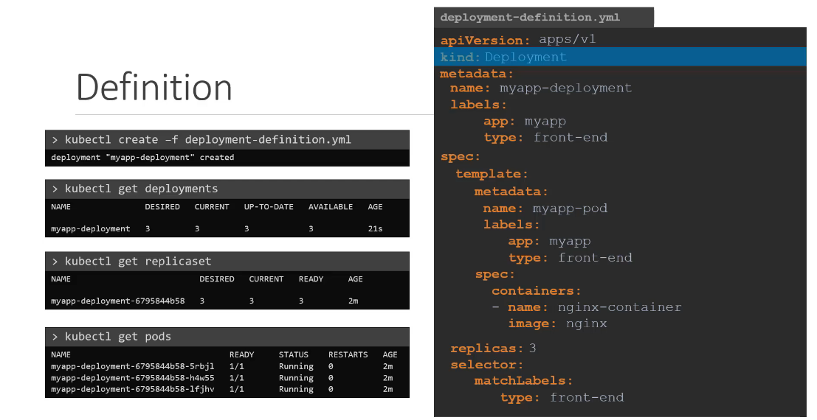

We will see how to take advantage of the deployment using the use cases we discussed in the previous

slide in the upcoming lectures and one more note before we end this lecture.

To see all the created objects at once run the kubectl get all command and in this case we can see that the deployment was created and then we have the replica set followed by three pods that were created as Pod of the deployment.

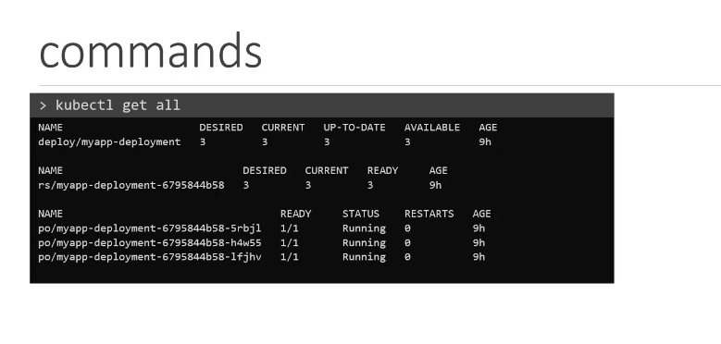

## ---

## apiVersion: apps/v1

## kind: Deployment

## metadata:

## name: http-frontend

## spec:

## replicas: 3

## selector:

## matchLabels:

## name: http-frontend

## template:

## metadata:

## labels:

## name: http-frontend

## spec:

## containers:

## - name: http-frontend

## image: httpd:2.4-alpine

## Namespace

There are two boys named Mark to differentiate them from each other.

We call them by their last names.

Smith and Williams they come from different houses.

Of course the Smiths and the Williams There are other members in the house.

The individuals within the house address each other simply by their first names.

For example the father addresses Mark simply as Mark.

However if the father wishes to address the mark in the other house he would use the full name someone

outside of these houses would also use the full name to refer to the boys or anyone within these houses.

Each of these houses have their own set of rules that defines who does what each of these houses have

their own set of resources that they can consume.

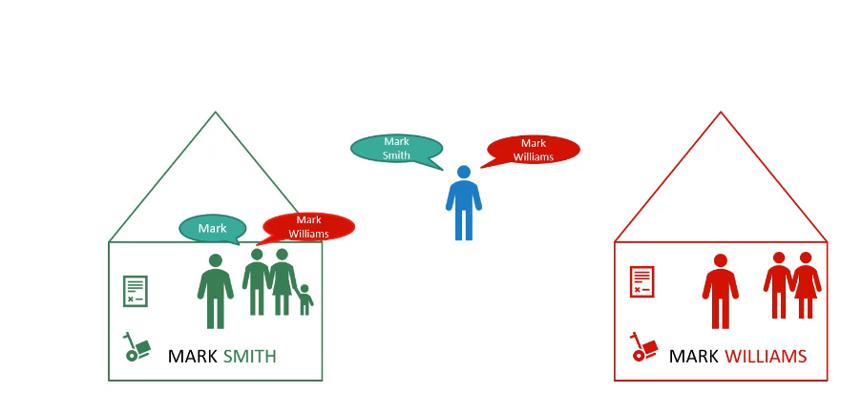

Now let's get back to kubernetes these houses correspond to namespaces in kubernetes.

So far in this course we've created objects such as pods deployments and services in our cluster.

Whatever we have been doing we have been doing within a namespace.

We were inside a house all this while this namespace is known as the default namespace and it is created

automatically kubernetes,

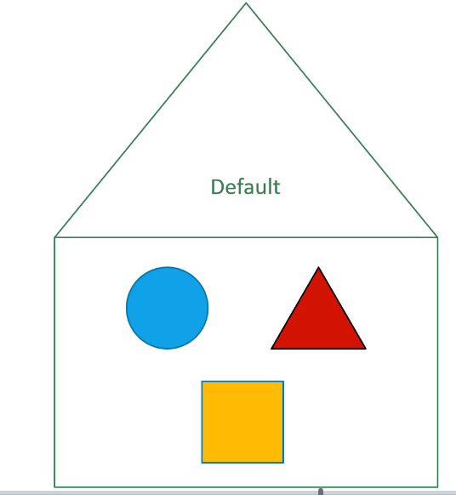

when the cluster is first set up kubernetes, creates a set of pods

and services for its internal purpose such as those required by the networking solution.

The DNS service etc. to isolate these from the user and to prevent you from accidentally deleting or modifying these services kubernetes creates them under another namespace created at cluster startup named Kube system a third namespace created by Coburn that is automatically is called kube public.

This is where resources that should be made available to all users are created.

If your environment is small or your learning and playing around with a small cluster you shouldn't

really have to worry about namespaces you could continue to work in the default namespace.

However as and when you grow and use a kubernetes cluster for enterprise or production purposes you may want to consider the use of namespace as you can create your own namespaces as well.

For example, if you wanted to use the same cluster for both dev and production environment but at the same time isolate the resources between them you can create a different namespace for each of them.

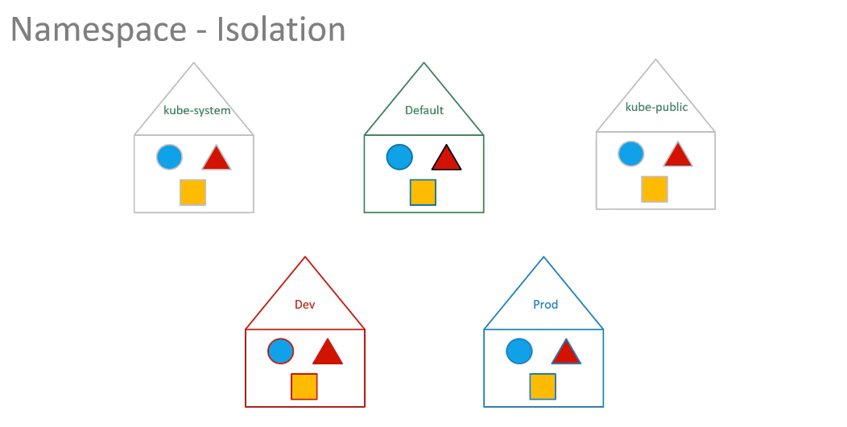

That way while working in the dev environment you don't accidentally modify a resources in production.

Each of these namespace can have its own set of policies that define who can do what.

You can also assign quota of resources to each of these named spaces that we each namespace is guaranteed

a certain amount and does not use more than it's allowed.

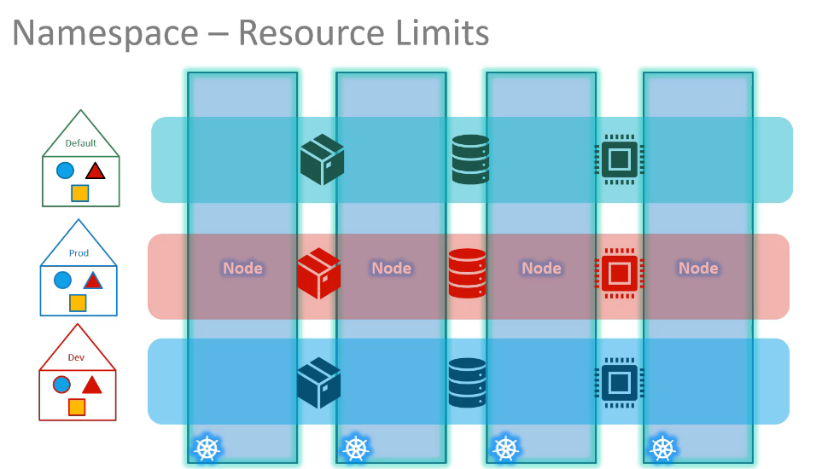

Limit going back to the default namespace that we have been working on just like how the members within

the House refer to each other by their first names.

The resources within a namespace can refer to each other simply by their names.

In this case the web app Pod can reach the db service simply using the hostname db service if required.

The Web app Pod can reach a service in another namespace as well.

For this you must append the name of the namespace to the name of the service.

For example for the web pod in the default namespace to connect to the database in the dev environment or namespace.

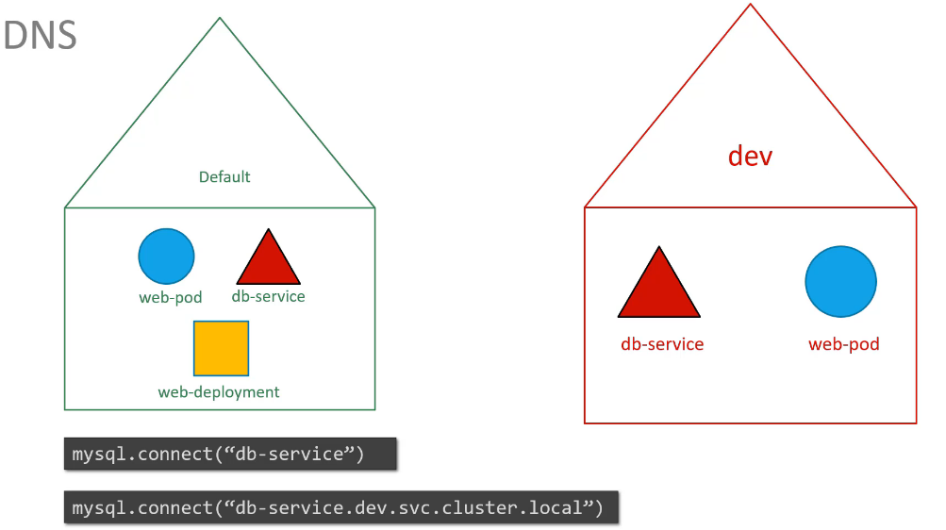

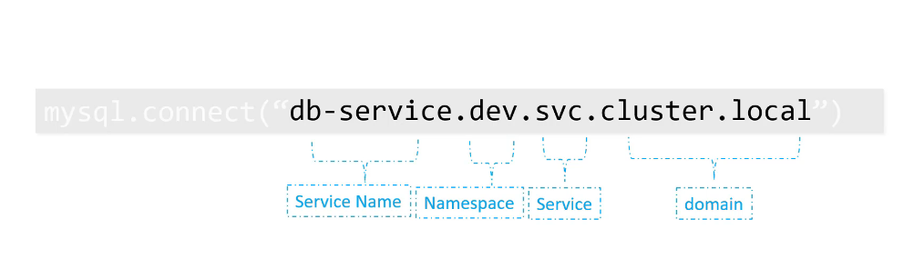

Use the servicename.namespace.svc.cluste.local format that would be db service.

Dev.SVC.cluster.local you're able to do this because when the service is created a DNS entry is added automatically in this format looking closely at the DNS name of the service.

The last Pod Cluster.local is the default domain name of the kubernetes cluster SVC is the subdomain for service followed by the namespace and then the name of the service itself.

Let us now look at some of the operational aspects of namespace.

Let's start with a Kube control commands.

For example, this command is used to list all the pods but it only lists the pods in the default namespace

to list pods in another namespace.

Use the namespace option in the command along with the name of the namespace.

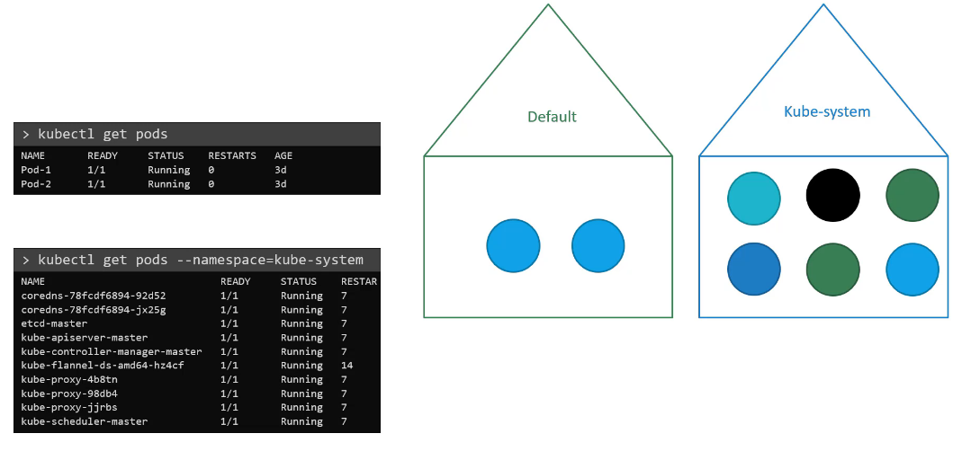

In this case Kube system here I have a pod definition file when you create a pod using this file.

The pod is created in the default namespace to create a pod in another namespace.

Use the namespace option if you want to make sure that this board gets created in the dev environment all the time.

Even if you don't specify the namespace in the command line you can move the namespace definition into the pod definition file like this under the metadata section.

This is a good way to ensure your resources are always created in the same namespace.

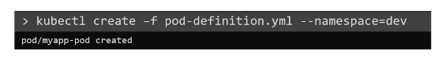

or

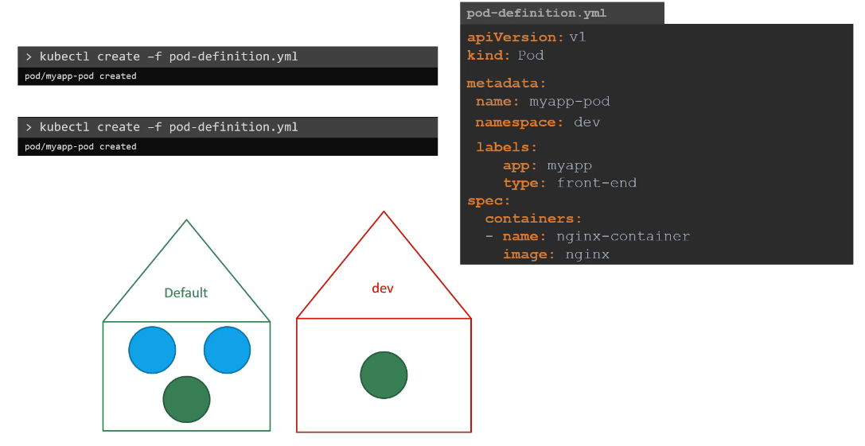

So how do you create a new namespace like any other object.

Use an namespace definition file the API version is V1 kind is namespace and under metadata specify

the name.

In this case.

Dev run the Kube control create command to create the namespace.

Another way to create a namespace is by simply running the command Kube control.

Create namespace followed by the name of the namespace now say we're working in three namespaces.

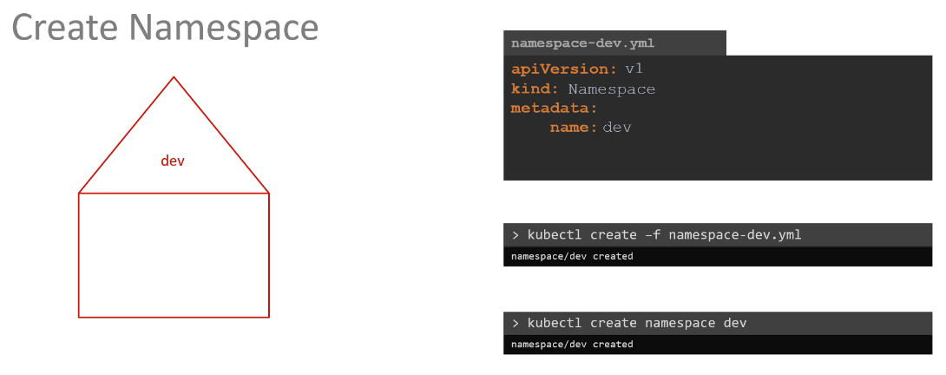

As we discussed before by default we are in the default namespace which is why we can see the resources

inside the default namespace using the kube control get pods command and to view those in the dev namespace.

We have to use the namespace option but what if we want to switch to the dev namespace permanently so

that we don't have to specify the namespace option anymore.

Well, in that case, use the Kube control config command to set the namespace in the current context.

Dev you can then simply run the Kube control get pods command without the namespace option to list pods

in the dev environment but you will need to specify the option for other environments such as default

or prod similarly you can switch to the prod namespace the same way.

Finally to view pods in all namespace use the all namespace option in the command.

This will list all the pods in all of the namespace is taking a closer look at the command.

This command first identifies the current context and then sets the namespace to the desired one for

that current context.

Well contexts are used to manage multiple clusters in multiple environments from the same management

system.

It is a totally separate topic to discuss and requires its own lecture so we will discuss context in

another lecture to limit resources in a namespace.

Create a resource quota to create one.

Start with a definition file for resource quota specify the namespace for which you want to create the

quota and then under spec provide your limits such as 10 pods 10 CPU units 10 GB byte of memory

etc..

Well that's it for this lecture.

Head over to the coding exercise and section and practice working with namespaces and I will see you

in the next lecture.

## TIP

**Create an NGINX Pod**

kubectl run --generator=run-pod/v1 nginx --image=nginx

**Generate POD Manifest YAML file (-o yaml). Don't create it(--dry-run)**

kubectl run --generator=run-pod/v1 nginx --image=nginx --dry-run -o yaml

kubectl run --restart=Never --image=busybox static-busybox --dry-run -o yaml --command -- sleep 1000

kubectl run nginx --image=nginx

**Create a deployment**

kubectl run --generator=deployment/v1beta1 nginx --image=nginx

kubectl create deployment my-dep --image=busybox

kubectl run blue --image=nginx --replicas=6

**Generate Deployment YAML file (-o yaml). Don't create it(--dry-run)**

kubectl run --generator=deployment/v1beta1 nginx --image=nginx --dry-run -o yaml

**Generate Deployment YAML file (-o yaml). Don't create it(--dry-run) with 4 Replicas (--replicas=4)**

kubectl run --generator=deployment/v1beta1 nginx --image=nginx --dry-run --replicas=4 -o yaml

**Save it to a file - (If you need to modify or add some other details before actually creating it)**

kubectl run --generator=deployment/v1beta1 nginx --image=nginx --dry-run --replicas=4 -o yaml > nginx-deployment.yaml

|  |
| --- |
| * all  * certificatesigningrequests (aka 'csr')  * clusterrolebindings  * clusterroles  * componentstatuses (aka 'cs')  * configmaps (aka 'cm')  * controllerrevisions  * cronjobs  * customresourcedefinition (aka 'crd')  * daemonsets (aka 'ds')  * deployments (aka 'deploy')  * endpoints (aka 'ep')  * events (aka 'ev')  * horizontalpodautoscalers (aka 'hpa')  * ingresses (aka 'ing')  * jobs  * limitranges (aka 'limits')  * namespaces (aka 'ns')  * networkpolicies (aka 'netpol')  * nodes (aka 'no')  * persistentvolumeclaims (aka 'pvc')  * persistentvolumes (aka 'pv')  * poddisruptionbudgets (aka 'pdb')  * podpreset  * pods (aka 'po')  * podsecuritypolicies (aka 'psp')  * podtemplates  * replicasets (aka 'rs')  * replicationcontrollers (aka 'rc')  * resourcequotas (aka 'quota')  * rolebindings  * roles  * secrets  * serviceaccounts (aka 'sa')  * services (aka 'svc')  * statefulsets (aka 'sts')  * storageclasses (aka 'sc') |

Top of Form

Bottom of Form

## Scheduler – no pod

What do you do when you do not have a scheduler in your cluster?

You, probably do not want to rely on the built in scheduler and instead want to schedule the PODs yourself.

So how exactly does a scheduler work in the backend.

Let's start with a simple pod definition file.

Every POD has a field called NodeName that, by default, is not set.

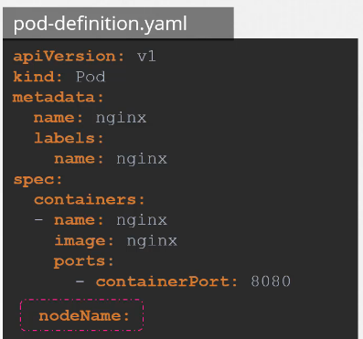

You don’t typically specify this field when you create the manifest file, Kubernetes adds it automtically.

The scheduler goes through all the pods and looks for those that do not have this property set.

Those are the candidates for scheduling.

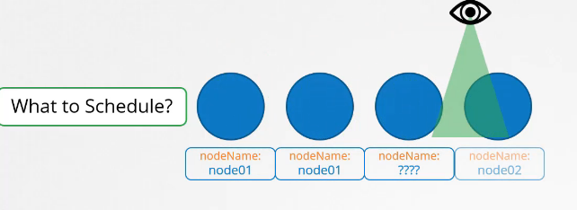

It then identifies the right node for the POD, by running the scheduling algorithm.

Once identified it schedules the POD on the Node by setting the node Name property to the name of the node by creating a binding object.

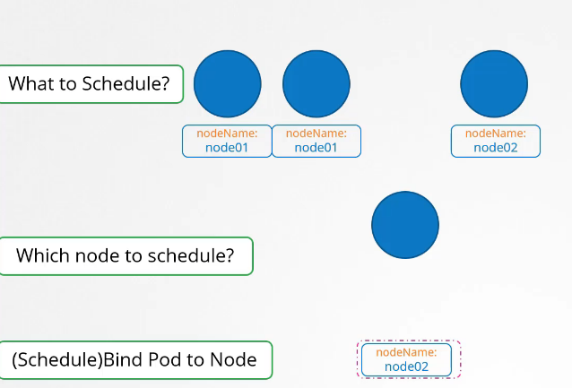

So if there is no scheduler to monitor and schedule nodes what happens?

The pods continue to be in a pending state.

So what can you do about it.

You can manually assign pods to node yourself. Well without a scheduler,

the easiest way to schedule a pod is to simply set the node name field to the name of the node in your pod specification while creating the POD.

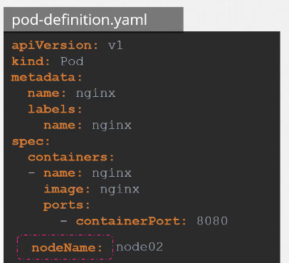

The pod then gets assigned to the specified node. You can only specify the node name at creation time.

What if the pod is already created and you want to assign the pod to a node? Kubernetes won’t allow you to modify the node Name property of a pod.

So another way to assign a note to an existing pod is to create a binding object and send a post request

to the pod binding API thus mimicking what the actual scheduler does. In the binding object you specify

a target node with the name of the node. Then send a post request to the pods binding API with the data set to the binding object in a JSON format.

So you must convert the YAML file into its equivalent JSON format.

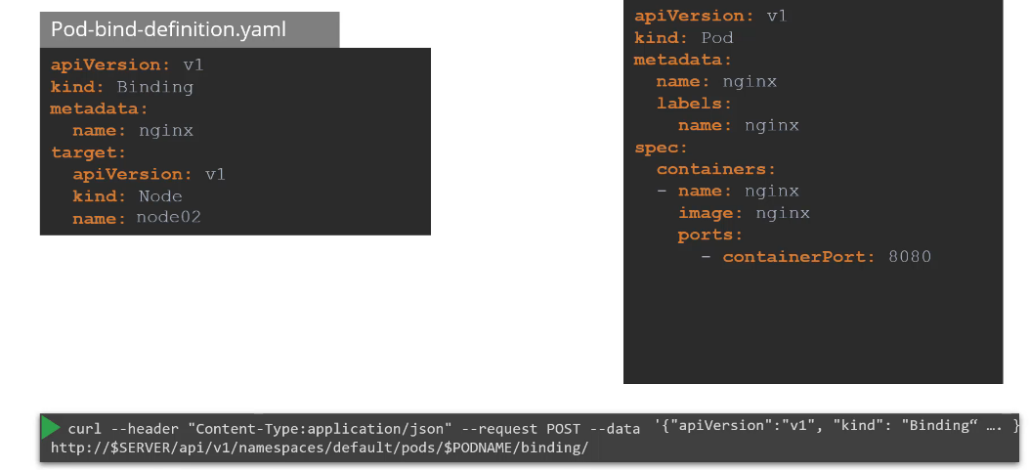

## Labels

Say you have a set of different species.

A user wants to be able to filter them based on different criteria such as based on their class or kind if they are domestic or wild or see by their color and not just group.

You want to be able to filter them based on a criteria such as all green animals or with multiple criteria such as everything green.

That is also a bird. Whatever that classification may be you need the ability to group things together and filter them based on your needs and the best way to do that is with labels. Labels or properties attached to each item.

So you add properties to each item for their class, kind and color selectors help you filter these items.

For example when you say class equals mammal we get a list of mammals and when you say color equals green we get the green mammals we see labels and selectors used everywhere such as the keywords you

tag to YouTube videos or blogs that help users filter and find the right content we see labels added

to items in an online store that help you add different kinds of filters to view your products.

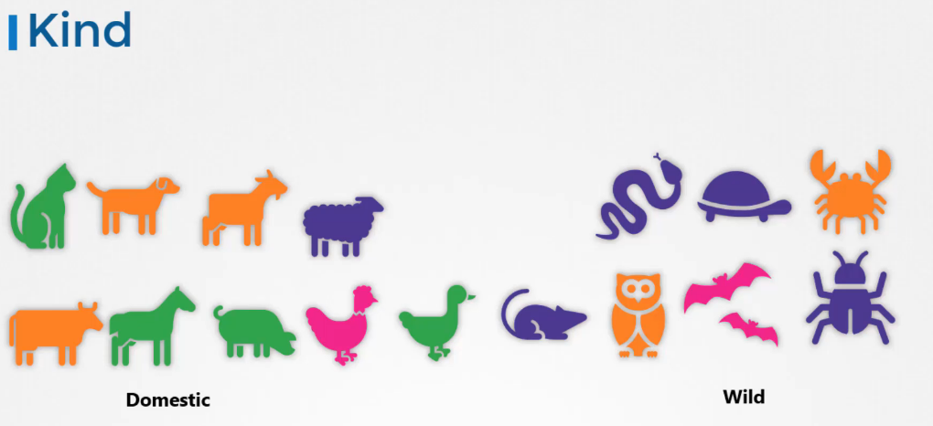

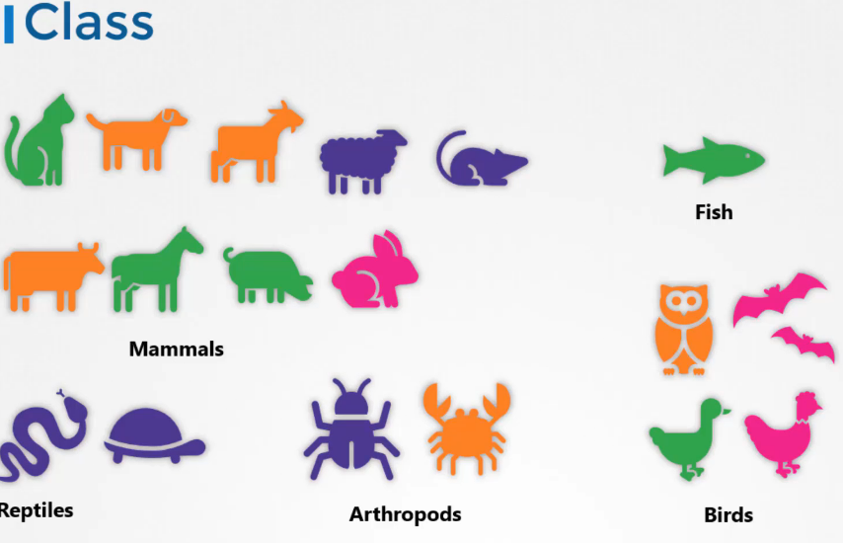

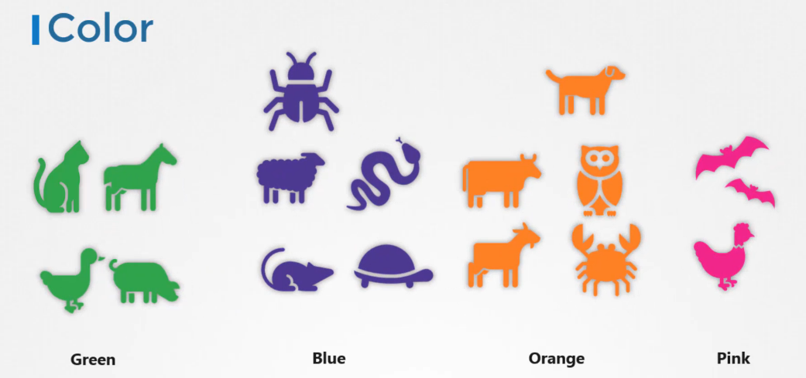

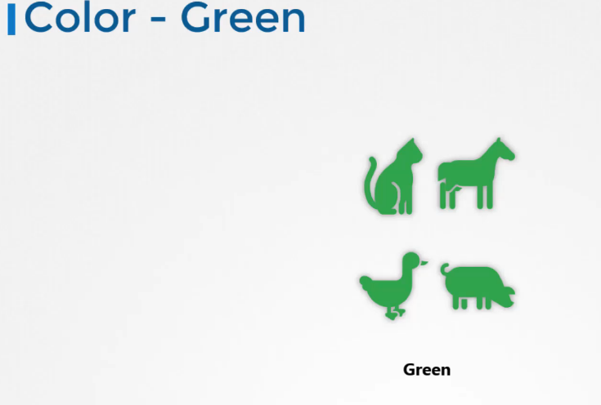

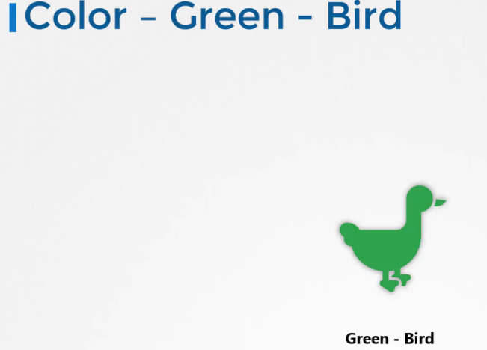

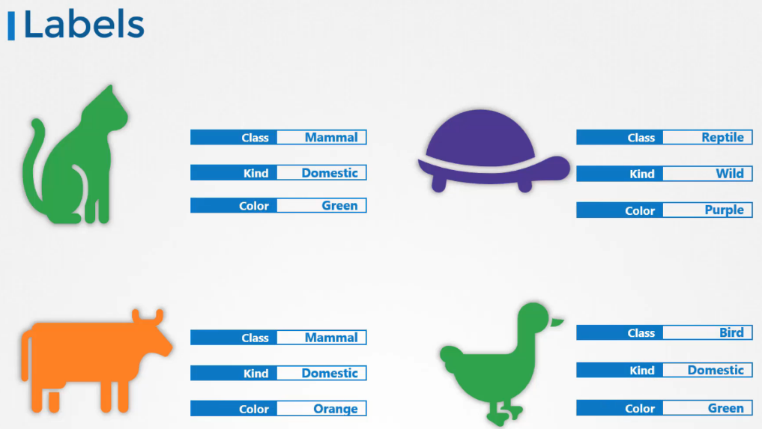

So how are labels and selectors used in Kubernetes?

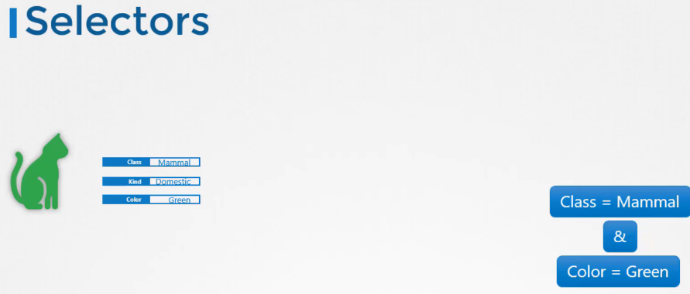

We have created a lot of different types of Objects in Kuberentes. Pods, Services, ReplicaSets and Deployments.

etc. For Kubernetes, all of these are different objects.

Over time you may end up having hundreds or thousands of these objects in your cluster.

Then you will need a way to filter and view different objects by different categories such as to group objects by their type or view objects by application or by their functionality whatever it may be.

You can group and select objects using labels and selectors for each object attach labels as per your needs, like app, function etc.

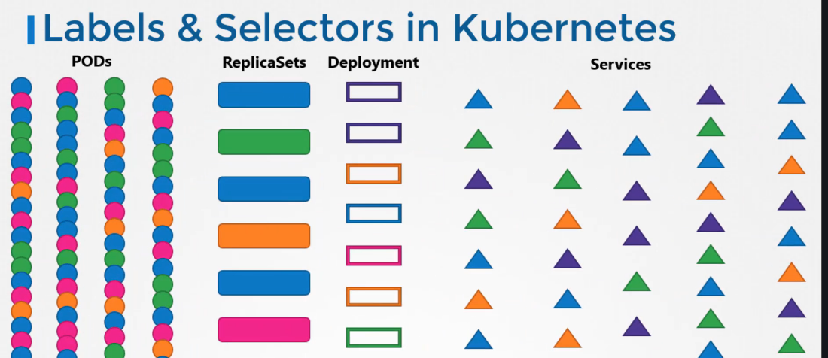

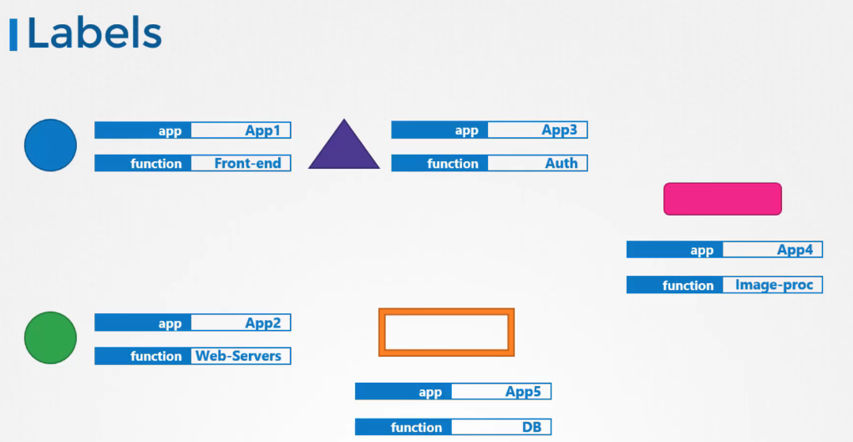

Then while selecting specify a condition to filter specific objects.

For example app == App1. So how exactly do you specify labels in kubernetes.

In a pod-definition file, under metadata,

create a section called labels. Under that add the labels in a key value format like this.

You can add as many labels as you like.

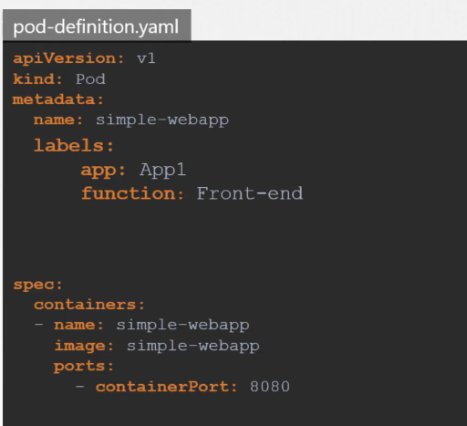

Once the pod is created, to select the pod with the labels

use the kubectl get pods command along with the selector option, and specify the condition like app=App1.

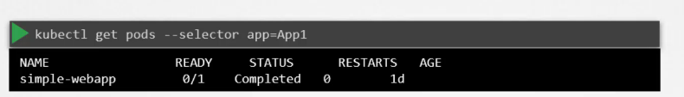

Now this is one use case of labels and selectors. Kubernetes objects use labels and selectors internally to connect different objects together.

For example to create a replicaset consisting of 3 different

pods, we first label the pod definition and use selector in a replicaset to group the pods .

In the replica-set set definition file.

You will see labels defined in two places.

Note that this is an area where beginners attempt to make a mistake.

The labels defined under the template section are the labels configured on the pods. The labels you see at the top are the labels of the replicas set itself.

We're not really concerned about the labels of the replica set for now because we are trying to get the replica set to discover the pods.

The labels on the replica set will be used if you were to configure some other object to discover the replica set in order to connect the replica set to the pod we configure the selector field under the replica set specification to match the labels defined on the pod a single label will do if it matches correctly.

However if you feel there could be other pods with the same label but with a different function then you could specify both the labels to ensure that the right pods are discovered by the replica set on creation.

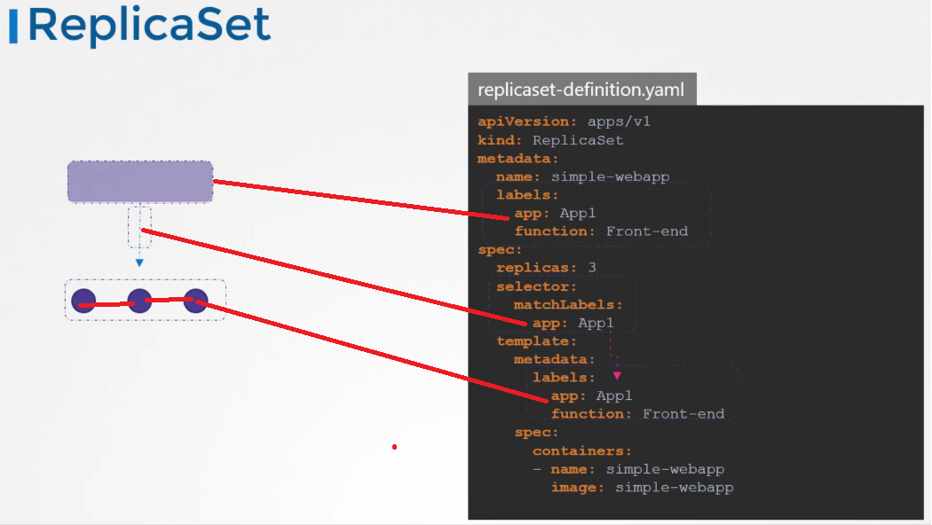

If the labels match the replica set is created successfully it works the same for other objects like

a service when a service is created it uses the selector defined in the service definition file to match

the labels set on the pods in the replica set definition file.

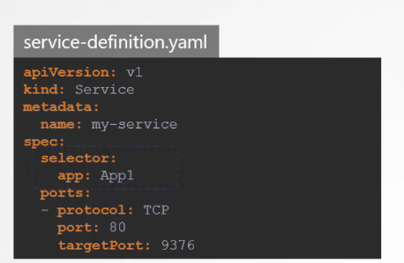

Finally let’s look at annotations. While labels and selectors are used to group and select objects, annotations are used to record other details for inflammatory purpose.

For example tool details like name, version build information etc or contact details, phone numbers, email

ids etc, that may be used for some kind of integration purpose.

master $ kubectl get pods --selector env=dev

NAME READY STATUS RESTARTS AGE

app-1-5nvbn 1/1 Running 0 1m

app-1-dkzg8 1/1 Running 0 1m

app-1-wn6xk 1/1 Running 0 1m

db-1-bb72k 1/1 Running 0 1m

db-1-nphv5 1/1 Running 0 1m

db-1-q2r64 1/1 Running 0 1m

db-1-sgwlq 1/1 Running 0 1m

master $ kubectl get pods --selector env=dev

NAME READY STATUS RESTARTS AGE

app-1-5nvbn 1/1 Running 0 1m

app-1-dkzg8 1/1 Running 0 1m

app-1-wn6xk 1/1 Running 0 1m

db-1-bb72k 1/1 Running 0 1m

db-1-nphv5 1/1 Running 0 1m

db-1-q2r64 1/1 Running 0 1m

db-1-sgwlq 1/1 Running 0 1m

## Taits and tolerations

.In this lecture we will discuss about the Pod to note relationship and how you can restrict what parts are placed on what notes the concept of taints and toleration can be a bit confusing for beginners.

So we will try to understand what they are using an analogy of a bug approaching a person.

Now my apologies in advance but this is the best I could come up with to prevent the bug from landing on the person.

We spray the person with a repellent(insecticide) spray or attained as we will call it.

In this lecture the book is intolerant to the smell.

So on approaching the person detained applied on the person throws the bug off however there could be

other books that are tolerant to the smell and so the taint doesn't really affect them.

And so they end up landing on the person.

So there are two things that decide if a bug can land on a person.

First the taint on the person.

And second the bugs toleration level to that particular taint

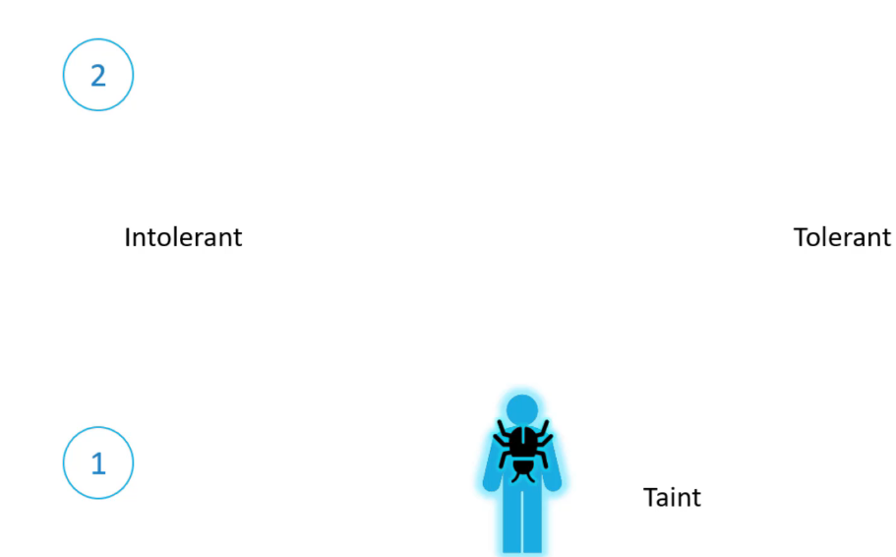

Getting back to Kube NET is the person is a node and the bugs are pods.

Now tains and toleration have nothing to do with security or intrusion on the Cluster.

Tains and toleration are used to set restrictions on what parts can be scheduled.

On a note let us start with a simple cluster with three worker notes the notes are named one two and

three.

We also have a set of paths that are to be deployed on these notes.

Let's call them A B C and D.

When the parts are created common it is scheduler tries to place these parts on the available worker

nodes.

As of now there are no restrictions are limitations and as such the scheduler places the parts across

all of the nodes to balance them out equally.

Now let us assume that we have dedicated resources on Node 1 for a particular use case or application

so we would like only those parts that belong to this application to be placed on Node 1.

First we prevent all parts from being placed on the Node by placing a taint on the Node.

Let's call it blue by default.

Paths have no toleration which means unless specified otherwise none of the parts can tolerate any taint.

So in this case none of the parts can be placed on Node 1 as none of them can tolerate the team.

Blue this solves half of our requirement no unwanted parts are going to be placed on this note.

The other half is to enable certain parts to be placed on this note.

For this we must specify which parts are tolerant to this particular attempt.

In our case we would like to allow only Pod D to be placed on this note so we add a toleration to Part

D.

Part D is now tolerant to blue so when the scheduler tries to place this Pod on Node 1 it goes through

Node 1 can now only accept parts that can tolerate the taint. Blue so with all the tains and toleration is in place. This is how the parts would be scheduled. The scheduler tries to place Pod a on not one but due to the team it is thrown off and it goes to note to the scheduler then tries to place Pod B on not one but again due to the taint it is thrown off and

is placed on Node 3 which happens to be the next free node.

The scheduler then tries to place Pod c to the Node 1 it is thrown off again and ends up on Node 2. Finally the scheduler tries to place Pod D on Node 1 since the Pod is tolerant to Node 1. It goes through so remember trains are set on nodes and toleration are set on pods.

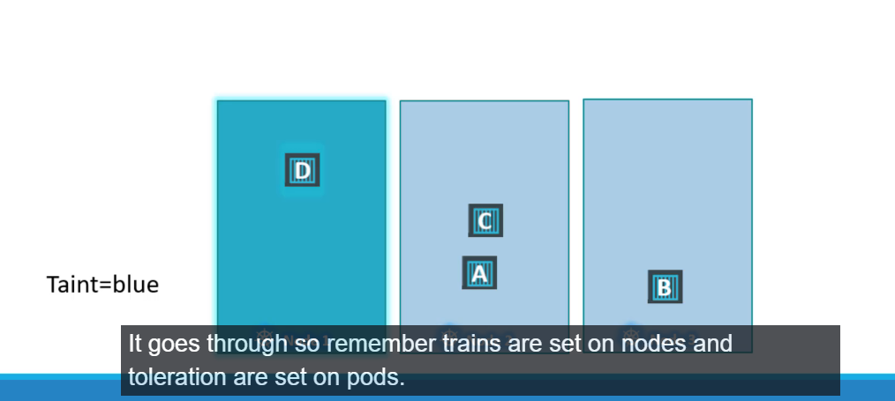

So how do you do this.

Use the cube control taint nodes command to taint in node specify the name of the node to train followed by the train itself which is a key value pair.



Key=value exp app=blue

For example if you would like to dedicate the Node 2 parts in application blue then the key value pair

would be app=blue the taint effect defines what would happen to the pods.

If they do not tolerate the taint there are three taint effects no schedule which means the pod will not be scheduled on the node which is what we have been discussing.

Prefer No schedule which means the system will try to avoid placing a pod on the node but that is not guaranteed.

And third is no execute.

Which means that new pods will not be scheduled on the node and existing parts on the node if any will be evicted if they do not tolerate the taint.

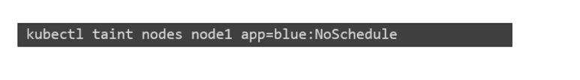

These parts may have been scheduled on Node before the 10th was applied to the node.

An example command would be detained Node node one with the key value pair app equals blue and an effect

of no schedule toleration is are added to parts to add a toleration to a pod.

First pull up the pod definition file in the spec section of the pod definition file had a section called

toleration move the same values used to while creating the taint under this section.

The key is app operator is equal value is blue and the effect is no should you.

And remember all of these values need to be encoded in double codes.

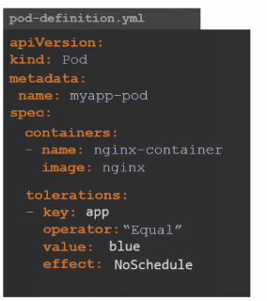

When the pods are now created or updated with the new toleration they are either not scheduled on nodes or evicted from the existing nodes depending on the effect set let us try to understand the No.

Execute takes effect in a bit more depth.

In this example we have three nodes running some workload.

We do not have any tains or toleration at this point so they are scheduled this way.

We then decided to dedicate Node 1 for a special application and as such we obtained the node with the

application name and add a toleration to the Pod that belongs to the application which happens to be

part D.

In this case while tending the node we set the taint effect to no execute and as such.

Once detained on the Node takes effect it evokes Pod C from the node which simply means that the part

is killed.

The Pod D continues to run on the node as it has a toleration to the change.

Now going back to our original scenario where we have tains and toleration is configured.

Remember tains and toleration are only meant to restrict nodes from accepting certain parts.

In this case node one can only accept Pod D but it does not guarantee that Pod D will always be placed

on Node 1.

Since there are no tains or restrictions applied on the other two nodes Pod D may very well be placed

on any of the other two nodes so remember tains and toleration does not tell the Pod to go to a particular

node.

Instead it tells the node to only accept parts with certain toleration.

If your requirement is to restrict a Pod to certain nodes it is achieved through another concept called

Ask node affinity which we will discuss in the next lecture finally.

While we're on this topic let us also take a look at an interesting fact.

So far we have only been referring to the worker nodes.

But we also have master nodes in the cluster which is technically just another note that has all the

capabilities of hosting a part.

Plus it runs all the management software.

Now I'm not sure if you noticed the scheduler does not schedule any Pod on the master node.

Why is that when the covenant is cluster is first setup.

It teams is set on the master node automatically that prevents any parts from being schedule on this

note.

You can see this as well as modified his behavior if required.

However a best practice is to not deploy application workloads on a master server to see this taint

run a cube.

Control described node command with Cube master as the node name and look for the tail section.

You will see a taint set to not schedule any parts on the master node.

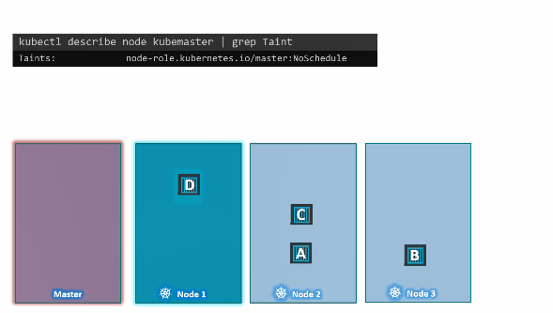

master $ kubectl taint nodes node01 spray=mortein:NoSchedule

node/node01 tainted

master $ kubectl describe node node01 | grep Taint

Taints: spray=mortein:NoSchedule

Remove a taint

kubectl taint nodes master node-role.kubernetes.io/master:NoSchedule-

To remove the taint added by the command above, you can run:

kubectl taint nodes node1 key:NoSchedule-

master $ kubectl taint nodes node01 cust=:NoSchedule

node/node01 tainted

master $ kubectl describe node node01 | grep Tain

Taints: cust:NoSchedule

## NodeSelector

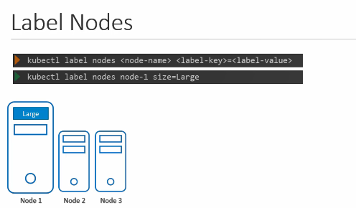

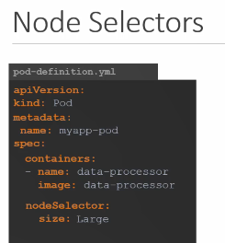

## Node Affinity

The primary purpose of node affinity feature is to ensure that pods are hosted on particular nodes.

In this case to ensure the large data processing pod ends up on no one in the previous lecture we did

this easily using notes selectors we discussed that you cannot provide advanced expressions like or

or not with node selectors the node affinity feature provides us with advanced capabilities to limit

pod placement on specific nodes with great power comes great complexity.

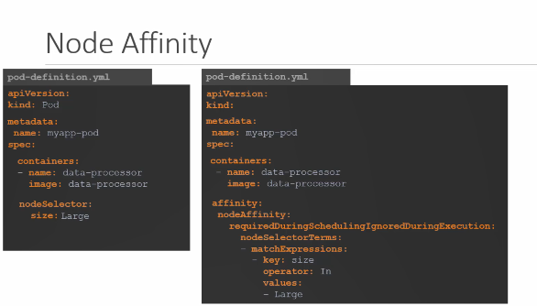

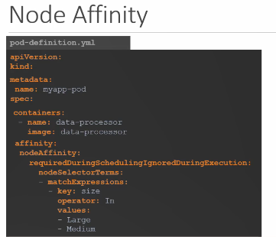

Operator : In, NotIn, Exists (only check that label exists)

So the simple node selector specification will now look like this with node affinity although both does

exactly the same thing plays the pod on the large node let us look at it a bit closer under spec you

have affinity and then node affinity under that and then you have a property that looks like a sentence

called required during scheduling ignored during execution no description needed for that and then you

have the node selector terms that is an array and that is where you will specify the key and value pairs

the key value pairs are in the form key operator and value where the operator is in the operator ensures

that the pod will be placed on a node whose label size has any value in the list of values specified

here in this case it is just one called large.

If you think your part could be placed on a large or a medium node you could simply add the value to

the list of values like this you could use the not in operator to say something like size not in small

where node affinity will match the node with a size not set to small.

We know that we have only set the labels size too large and medium nodes the smaller nodes don't even

have the labels set.

So we don't really have to even check the value of the label as long as we are sure we don't set a label

size to the smaller nodes using the exists operator will give us the same result.

The exists the operator will simply check if the label size exists on the notes and you don't need the

values section for that as it does not compare the values.

There are a number of other operators as well.

Check the documentation for specific details.

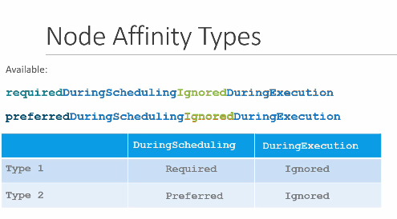

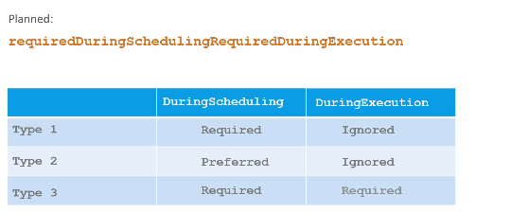

Now we understand all of this and we're comfortable with creating a pod with specific affinity rules

when the pods are created.

These rules are considered and the pods are placed onto the right nodes.

But what if node affinity could not match a node with a given expression.

In this case what if there are no nodes with a label called size say we had the labels and the pods

are scheduled.

What if someone changes the label on the node at a future point in time.

Will the pod continue to stay on the Node.

All of this is answered by the long sentence like property under node affinity which happens to be the

type of node affinity the type of node affinity defines the behaviour of the scheduler with respect to

node affinity and the stages in the lifecycle of the pod.

There are currently two types of node affinity available required during scheduling ignored during execution

and preferred during scheduling ignored during execution and there are additional types of node affinity

planed.

As of this recording required during scheduling required during execution we will now break this down

to understand further.

We will start by looking at the two available affinity types.

There are two states in the lifecycle of a pod when considering node affinity during scheduling and

during execution during scheduling.

Is the state where a pod does not exist and is created for the first time.

We have no doubt that when a pod is first created the affinity rules specified are considered to place

the pods on the right note.

Now what if the nodes with matching labels are not available.

For example we forgot to label the node as large.

That is where the type of node affinity used comes into play.

If you select the required type which is the first one the scheduler will mandate that the pod be placed

on a node with a given affinity.

Rules if it cannot find one the pod will not be scheduled.

This type will be used in cases where the placement of the pod is crucial.

If a matching node does not exist the pod will not be scheduled.

But let's say the pod placement is less important than running the workload itself.

In that case you could set it to preferred and in cases where a matching node is not found.

The scheduler will simply ignore node affinity rules and place the card on any available note.

This is a way of telling the scheduler hey try your best to place the pod on matching node but if you

really cannot find one just plays it anywhere.

The second part of the property or the other state is during execution during execution is the state

where a part has been running and a change is made in the environment that affects node affinity such

as a change in the label of a node.

For example say an administrator removed the label we said earlier called size equals large from the

node.

Now what would happen to the pods that are running on the Node.

As you can see the two types of node affinity available today has this value set too ignored which means

pods will continue to run and any changes in node affinity will not impact them once they are scheduled.

The new types expected in the future only have a difference in the during execution phase a new option

called required during execution is introduced which will evict any pods that are running on notes

that do not meet affinity rules.

In the earlier example, a pod running on the large node will be evicted or terminated if the label large

is removed from the node.

Well that's it for this lecture.

Head over to the coding exercises and practice working with node affinity rules in the next lecture.

We will compare tables and toleration and node affinity.

Exp:  
apiVersion: extensions/v1beta1

kind: Deployment

metadata:

name: red

spec:

replicas: 3

selector:

matchLabels:

run: nginx

template:

metadata:

labels:

run: nginx

spec:

containers:

- image: nginx

imagePullPolicy: Always

name: nginx

affinity:

nodeAffinity:

requiredDuringSchedulingIgnoredDuringExecution:

nodeSelectorTerms:

- matchExpressions:

- key: node-role.kubernetes.io/master

operator: Exists

master $ cat /var/answers/blue-deployment.yaml

apiVersion: extensions/v1beta1

kind: Deployment

metadata:

name: blue

spec:

replicas: 6

selector:

matchLabels:

run: nginx

template:

metadata:

labels:

run: nginx

spec:

containers:

- image: nginx

imagePullPolicy: Always

name: nginx

affinity:

nodeAffinity:

requiredDuringSchedulingIgnoredDuringExecution:

nodeSelectorTerms:

- matchExpressions:

- key: color

operator: In

values:

- blue

## Resousece limits

Let us look at a 3 Node Kubernetes cluster. Each node has a set of CPU, Memory and Disk

resources available.

Every POD consumes a set of resources.

In this case 2 CPUs , one Memory and some disk space. Whenever a POD is placed on a Node, it consumes resources

available to that node. As we have discussed before, it is the kubernetes scheduler that decides which Node a POD goes to.

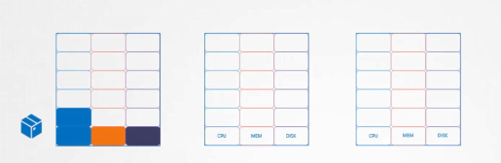

The scheduler takes into consideration, the amount of resources required by a POD

and those available on the Nodes. In this case, the scheduler schedules a new POD on Node 2. If the node has no sufficient resources, the scheduler avoids placing the POD on that node Instead places the POD on one where sufficient resources are available if there is no sufficient resources available on any of the nodes, Kubernetes holds back ( a retine) scheduling the POD, and you will see the POD in a pending state.

If you look at the events, you will see the reason – insufficient cpu.

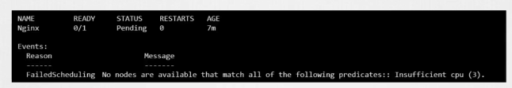

Let us now focus on the resource requirements for each POD. What are these blocks and what are their values?

By default, kubernetes assumes that a POD or a container within a POD requires 0.5 CPU & 256 Mebibyte of memory.

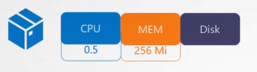

This is known as the resource request for a container the minimum amount of CPU or memory requested by the container when the scheduler tries to place the pod on a node.

It uses these numbers to identify a node which has sufficient amount of resources available.

Now if you know that your application will need more than these you can modify these values by specifying them in your pod or deployment definition files in the simple pod definition file. add a section called resources, under which add requests and specify the new values for memory and cpu usage.

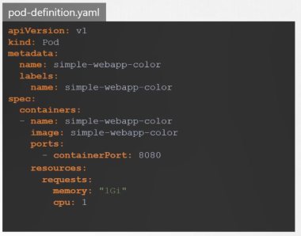

In this case I set it to 1GB of memory and 1 count of vCPU.

So what does 1 count of CPU really mean?

Remember these blocks are used for illustration purposes only.

It doesn't have to be in the increment of point five.

You can specify any value as low as 0.1cpu=100m

CPU can also be expressed as 100m were m stands for milli.

You can go as low as 1m, but not lower than that. 1 count of CPU is equivalent to 1 vCPU.

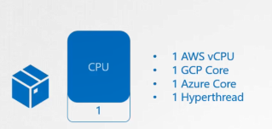

That’s 1 vCPU in AWS, or 1 Core in GCP or Azure or 1 Hyperthread. You could request a higher number of CPUs for the container, provided your Nodes are sufficiently funded. Similarly, with memory you could specify 256 Mebibyte using the Mi suffix. Or specify the same value in Memory like this. Or use the suffix G for a gigabyte.

Note the difference between G and Gi. G is Gigabyte and it refers to a 1000 Megabytes, whereas Gi

Gi refers to Gibibyte and refers to 1024 Mebibyte.

The same applies to megabyte and kilobytes.

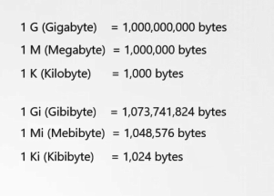

Let's now look at a container running on a node in the docker world a docker container has no limit to the resources it can consume on a Node. Say a container starts with 1 vCPU on a Node, it can go up and consume as much resource as it requires, suffocating the native processes on the node or other containers of resources.

However you can set a limit for the resource usage on these pods by default.

Kubernetes sets a limit of 1vCPU to containers. So if you do not specify explicitly, a container will be limited

to consume only 1 vCPU from the Node.

The same goes with memory. By default, kubernetes sets a limit of 512 Mebibyte on containers.

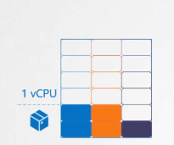

if you don't like the default limit you can change them by adding a limit section under the resources section in your pod definition file. Specify new limits for memory and cpu you like this when the pod is created, kubernetes sets new limits for the container.

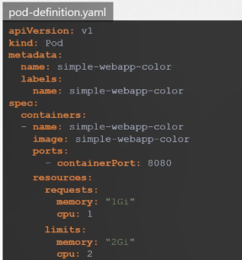

Remember that the limits and requests are set for each container within the pod.

So what happens when a pod tries to exceed resources beyond its specified limit.

In case of the CPU, kubernetes throttles the CPU so that it does not go beyond the specified limit.

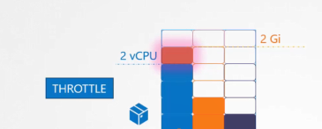

A container cannot use more CPU resources than its limit.

However, this is not the case with memory. A container CAN use more memory resources that its limit.

So if a pod tries to consume more memory than its limit constantly, the POD will be terminated.

## Daemon set

So far we have deployed various pods on different nodes in our cluster. With the help of replica sets and deployments we made sure multiple copies of our applications

applications are made available across various different worker nodes.

Daemon set are like replica sets, as in it helps

you deploy multiple instances of pod. But it runs one copy of your pod on each node in your cluster.

Whenever a new node is added to the cluster a replica of the pod is automatically added to that node and when a node is removed the pod is automatically removed.

The demon set ensures that one copy of the pod is always present in all nodes in the cluster.

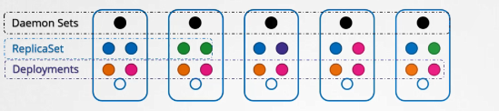

So what are some use cases of daemonsets?

Say you would like to deploy a monitoring agent or log collector on each of your nodes in the cluster

so you can monitor your cluster better.

Demon set is perfect for that as it can deploy your monitoring agent in the form of a pod

in all the nodes in your cluster. Then, you don’t have to worry about adding/removing monitoring agents

from these nodes when there are changes in your cluster.

as the daemon set will take care of that for you.

While discussing the kubernetes architecture we learned that one of the worker node components that

is required on every node in the cluster is a kube-proxy.

That is one good use case of daemon Sets. The kubeproxy component can be deployed as a daemon set in the cluster.

Another use case is for networking. Networking solutions like weave net requires an agent to be deployed on each node in the cluster.

We will discuss about networking concepts in much more detail later during this course but I just wanted to point it out here for now.

Creating a DaemonSet is similar to the ReplicaSet creation process.

It has nested pod specification under the template section and selectors to link the daemon set to the PODs. A daemonSet definition file has a similar structure.

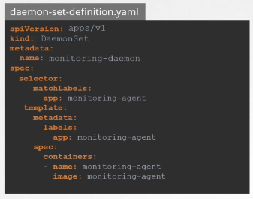

We start with apiVersion, kind,

metadata and spec. The api version is apps/v1. Kind is DaemonSet instead of ReplicaSet.

We will set the name to monitoring daemon. Under spec you have a selector and a pod specification

template.

It's almost exactly like ReplicaSet definition except that the kind is a demon set. Ensure the labels

in the selector matches the ones in the pod template. Once ready create the daemonset using the kubectl create daemonset command. To view the created daemonset run the kubectl get daemonset command.

And of course to view more details run the kubectl describe demonSet command.

So how does a demon set work.

How does it schedule pods on each node? and How does it ensure that every node has a pod? if you were asked to schedule a pod on each node in the cluster.

how would you do it? In one of the previous lectures in this section.

we discussed that we could set the nodeName property on the pod to bypass the scheduler and get the pod placed on a node directly. So that’s one approach. On each pod, set the nodeName property in its specification before it is created and when they are created, they automatically land on the respective nodes.

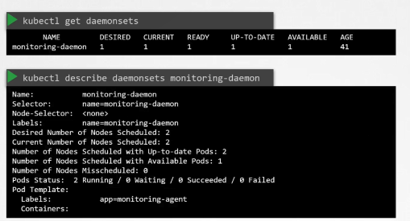

So that’s how it used to be until kubernetes version v1.12. From v1.12 onwards

the Daemon set uses the default scheduler and node affinity rules that we learned in one of the previous lectures to schedule pods on nodes.

## Static Pods

Earlier,in this course we talked about the Architecture and how the kubelet functions as one of the many control plane components in Kubernetes.

The kubelet relies on the kube-apiserver for instructions on what PODs to load on its node,

which was based on a decision made by the kube-scheduler which was stored in the ETCD datastore.

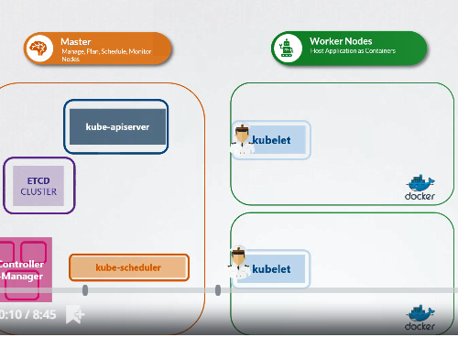

What if there was no kube-apiserver, and kube-scheduler and no controllers and no ETCD cluster.

What if there was no master at all. What if there were no other nodes.

What if you're all alone in the sea by yourself.

Not part of any cluster.

Is there anything that the kubelet can do as the captain on the ship?

Can it operate as an independent node?

If so who would provide the instructions required to create PODs?

Well, the kubelet can manage a node independently. On this ship…err..host,

we have the kubelet installed. And of course we have Docker as well to run containers.

There is no Kubernetes cluster. So there are no Kube API server or anything like that.

The one thing that the kubelet knows to do is create PODs. But we don’t have an API server here to provide

POD details.

By now we know that to create a POD you need the details of the POD in a POD definition file. But how

do you provide a pod definition file to the kubelet without a kube-api server?

You can configure the kubelet to read the pod definition files from a directory on the server designated to store information about pods.

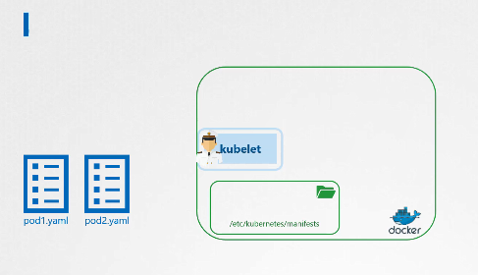

/etc/kubernetes/manifest

The pods definition files in this directory the Kubelet periodically checks this directory for files reads these files and creates pods on the host.

Not only does it create the pod it can ensure that the pod stays alive.

If the application crashes, the kubelet attempts to restart it.

If you make a change to any of the file within this directory, the kubelet recreates the pod for those changes to take effect.

If you remove a file from this directory the pod is deleted automatically.

So these PODs that are created by the kubelet on its own without the intervention from the API server or rest of the kuberentes cluster components are known as Static PODs. Remember you can only create PODs this way.

You cannot create replicasets or deployments or services by placing a definition file in the designated directory.

They are all concepts part of the whole Kubernetes architecture, that requires other control plane componentslike the replication and deployment controllers etc. The kubelet works at a POD level and can only understand PODs. Which is why it is able to create static pods

this way.

So what is that designated folder and how do you configure it.

It could be any directory on the host. And the location of that directory is passed in to the kubelet as a option while running the service.

The option is named pod manifest path

and here it is set to /etc/Kubernetes/manifests.

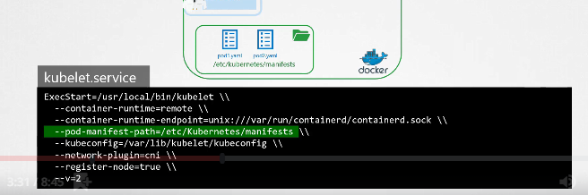

There is also another way to configure this. Instead of specifying the option directly in the kubelet.service file, you could provide a path to another config file using the config option, and define the directory path as staticPodPath in that file.

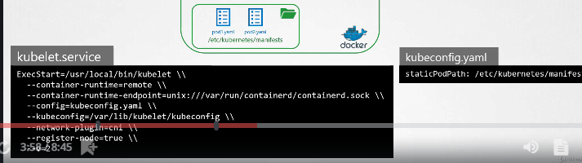

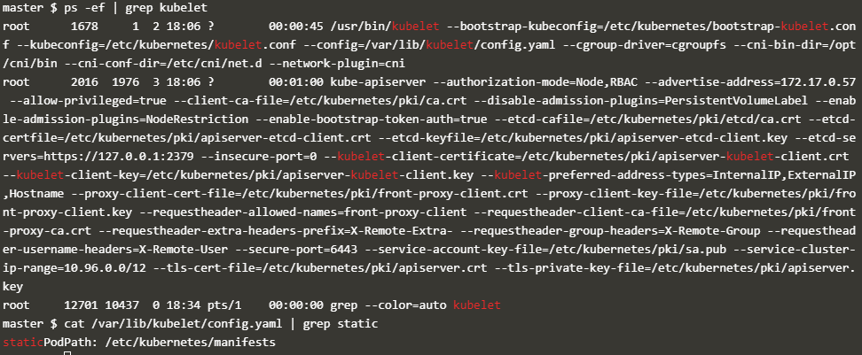

Clusters setup by the kubeadmin tool uses this approach. If you are inspecting an existing cluster, you should inspect this option of the kubelet to identify the path to the directory.

You will then know where to place the definition file for your static pods.

So keep this in mind when you go through the labs. You should know to view and configure this option irrespective of (indifferent de )the method used to set up the cluster first check the option pod manifest path in the

Kubelet service file if it's not there then look for the config option and identify the file used as

the config file and then within the config file look for these static pod path option.

Either of these should give you the right path once the static ports are created.

you can view them by running the Docker ps command. So why not the kubectl command as we have

been doing so far.

Remember we don’t have the rest of the Kubernetes cluster. Kubectl utility works with the

kube-apiserver.

Since we don’t have an API server now, no kubectl utility. which is why we're using the docker command.

So then how does it work when the node is part of a cluster.

When there is an API server requesting the Kubelet to create pods.

Can the kubelet create both kinds of PODs at the same time? Well, the way the kubelet works is it can take in requests for creating parts from different inputs.

The first is through the POD definition files from the static pods folder, as we just saw. The second, is through an HTTP API endpoint. And that is how the kube-apiserver provides

input to kubelet. The kubelet can create both kinds of PODs – the staticpods and the ones from the api server - at the same time.

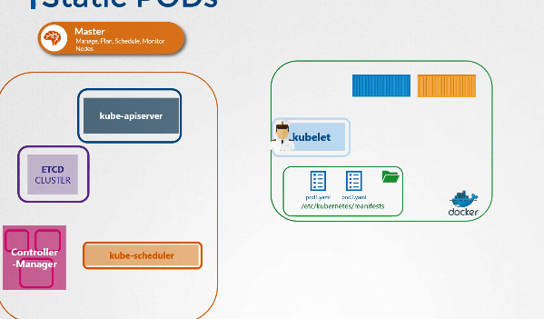

Well, in that case is the API server aware of the static pods created by the kubelet?

Yes it is.

If you run the kubectl get pods command on the master node, the static pods will be listed as any other pod.

Well how is that happening? When the kubelet creates a static pod,

if it is part of a cluster, it also creates a mirror object in the kubeapi server.

What you see from the kube-apiserver is just a read only mirror of the pod. You can view details about the pod but you cannot edit or delete it like the usual parts.

You can only delete them by modifying the files from the nodes manifest folder.

Note that the name of the part is automatically appended with the node name.

In this case node01. So then why would you want to use Static PODs?

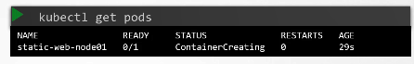

Since static pods are not dependent on the Kubernetes control plane, you can use static pods to deploy the control plane components itself as pods on a node. Start by installing kubelet on all the master nodes.

Then create pod definition files that uses Docker images of the various control plane components such as the api server, controller, etcd etc.

Place the definition files in the designated manifests folder. And kubelet takes care of deploying the control plane components themselves as PODs on the cluster.

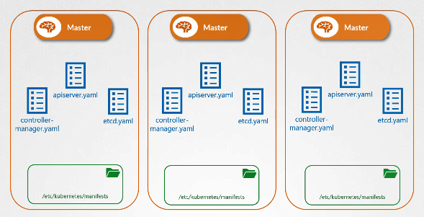

This way you don't have to download the binaries configure services or worry about so the service is crashing.

If any of these services were to crash since it's a static pod it will automatically be restarted by the kubelet. Neat and simple.

That’s how the kubeadmin tool set’s up a Kubernetes cluster.

Which is why when you list the pods in the kube-system namespace, you see the control plane components as PODs in a cluster setup by the kubeadmin tool.

We will explore that setup in the upcoming practice test. Before I let you go,

one question that I get often is about the different between Static PODs and DaemonSets.

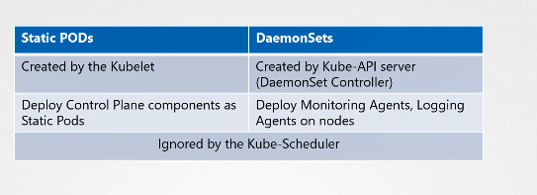

DaemonSets as we saw earlier are used to ensure one instance of an application is available on all nodes in the cluster. It is handled by a daemonset controller through the kube-api server. Whereas static pods, as we saw in this lecture, are created directly by the kubelet without any interference from the

kube-api server or rest of the Kubernetes control plane components. Static pods can be used to deploy

the Kubernetes control plane components itself. Both static pods and pods created by daemonsets are ignored by the kube-scheduler. The kube-scheduler has no affect on these pods.

## Multiple Schedulers

We have seen how the default-scheduler works in a kubernetes environment in the previous lectures.

It has an algorithm that distributes pods across nodes evenly as well as takes into consideration the various conditions we specify through taints & tolerations and node affinity etc. But what if none of these satisfies your needs?

Say you have a specific application that requires its components to be placed on nodes after performing some additional checks. So you decide to have your own scheduling algorithm to place pods on nodes? So that you can add your own custom conditions and checks in it. Kubernetes is highly extensible.

You can write your own kubernetes scheduler program, package it and deploy it as the default scheduler or as an additional scheduler in the kubernetes cluster.

That way all of the other applications can go through the default scheduler,

however one specific application can use your custom scheduler. Your kubernetes cluster can have multiple schedulers at the same time.

When creating a POD or a Deployment you can instruct kubernetes to have the POD

scheduled by a specific scheduler.

Earlier we saw how to deploy the kube-scheduler.

We download the kube-scheduler binary and run it as a service with a set of options.

One of the option is scheduler name. If not specified

It assumes in name of default scheduler.

This kube-scheduler is the default scheduler. To deploy an additional scheduler,

You can use the same kube-scheduler binary or use one that you might have built for yourself, which makes more sense.

In this case we are going to use the same binary to deploy the additional scheduler.

This time we set the scheduler name to a custom name.

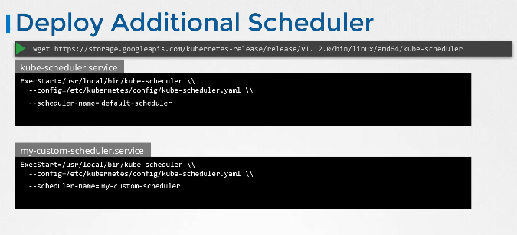

This is important to differentiate the two schedulers and this is the name that we will be specifying in the pod definition file later on.

Let’s take a look at how it works with the kubeadm tool. The kubeadm tool deploys the scheduler as a POD.

You can find the definition file it uses under the manifests folder. I have removed all the other details from the file so we can focus on the key parts.

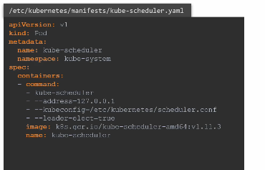

The command section has the command and associated options to start the scheduler.

We can create a custom scheduler by making a copy of the same file, and by changing the name of the scheduler.

We set the name of the pod to my-custom-scheduler and we add a new option to the scheduler command to set a custom name for the scheduler.

Finally an important option to look here is the leader-elect option. The leader-elect

option is used when you have multiple copies of the scheduler running on different master nodes, in a High Availability setup where you have multiple master nodes with the kube-scheduler process running on both of them.

If multiple copies of the same scheduler are running on different nodes only one can be active at a time.

That’s where the leader-elect option helps in choosing a leader who will lead scheduling activities. We will discuss more about HA setup in another section, but for now I wanted

to point out that, to get multiple schedulers working you must either set the leader-elect option to false, in case where you don’t have multiple masters.

In case you do have multiple masters, you can pass in an additional parameter to set a lock object name.

This is to differentiate the new custom scheduler from the default during the leader election process.

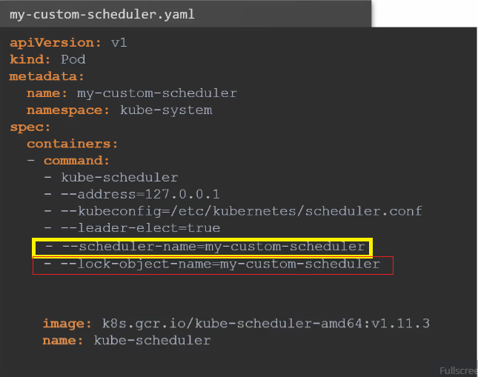

Once done, create the pod using the kubectl create command. Run the get pods command in the kube-system namespace and look for the new custom scheduler.

Make sure its in a running state. The next step is to configure a new POD or a deployment to use the new scheduler.

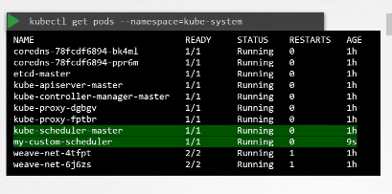

In the Pod specification file.

add a new field called schedulerName and specify the name of the new scheduler.

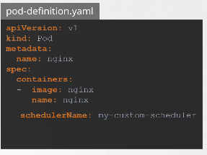

This way when the pod is created, the right scheduler picks it up to schedule. Create the pod using the kubectl create command. If the scheduler was not configured correctly, then the pod will continue to remain in a Pending state. If everything is good, then the pod will be in a Running state.

So how do you know which scheduler picked it up? View the events using the kubectl get events command.

This lists all the events in the current namespace.

Look for the Scheduled events. As you can see the source of the event is the custom scheduler we created.

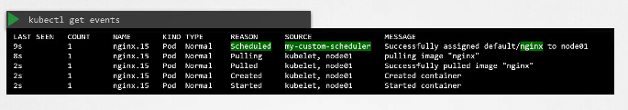

And the message says successfully assigned default/nginx image. To view the logs of the scheduler, view the logs of the pod using the kubectl logs command. Specify the name of the scheduler the correct namespace.

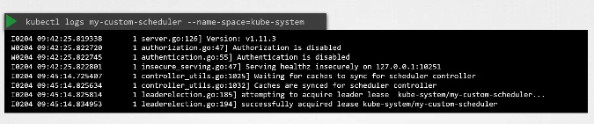

* --leader-elect=false
* --port=10282
* --scheduler-name=my-scheduler